|  |
| --- |
| GATE 2026 |
| Algorithm’s Short Notes with PYQ’s and Test |
| With some Hints and Advices |

|  |
| --- |
| VARUN KUMAR  20-06-2025 |

1. **Short Notes**

Ink Drawings
Ink Drawings
Ink Drawings
Ink Drawings
Ink Drawings
Ink Drawings
Ink Drawings
Ink Drawings
Ink Drawings
Ink Drawings
Ink Drawings
Ink Drawings
Ink Drawings
Ink Drawings
Ink Drawings
Ink Drawings
Ink Drawings
Ink Drawings
Ink Drawings
Ink Drawings
Ink Drawings
Ink Drawings
Ink Drawings
Ink Drawings
Ink Drawings
Ink Drawings
Ink Drawings
Ink Drawings
Ink Drawings
Ink Drawings
Ink Drawings
Ink Drawings
Ink Drawings
Ink Drawings
Ink Drawings
Ink Drawings
Ink Drawings
Ink Drawings
Ink Drawings
Ink Drawings
Ink Drawings
Ink Drawings
Ink Drawings
Ink Drawings
Ink Drawings
Ink Drawings
Ink Drawings
Ink Drawings
Ink Drawings
Ink Drawings
Ink Drawings
Ink Drawings
Ink Drawings
Ink Drawings
Ink Drawings
Ink Drawings
Ink Drawings
Ink Drawings
Ink Drawings
Ink Drawings
Ink Drawings
Ink Drawings
Ink Drawings
Ink Drawings
Ink Drawings
Ink Drawings
Ink Drawings
Ink Drawings
Ink Drawings
Ink Drawings
Ink Drawings
Ink Drawings
Ink Drawings
Ink Drawings
Ink Drawings
Ink Drawings
Ink Drawings
Ink Drawings
Ink Drawings
Ink Drawings
Ink Drawings
Ink Drawings
Ink Drawings
Ink Drawings
Ink Drawings
Ink Drawings
Ink Drawings
Ink Drawings
Ink Drawings
Ink Drawings
Ink Drawings
Ink Drawings
Ink Drawings
Ink Drawings
Ink Drawings
Ink Drawings
Ink Drawings
Ink Drawings
Ink Drawings
Ink Drawings
Ink Drawings
Ink Drawings
Ink Drawings
Ink Drawings
Ink Drawings
Ink Drawings
Ink Drawings
Ink Drawings
Ink Drawings
Ink Drawings
Ink Drawings
Ink Drawings
Ink Drawings
Ink Drawings
Ink Drawings
Ink Drawings
Ink Drawings
Ink Drawings
Ink Drawings
Ink Drawings
Ink Drawings
Ink Drawings
Ink Drawings
Ink Drawings
Ink Drawings
Ink Drawings
Ink Drawings
Ink Drawings
Ink Drawings
Ink Drawings
Ink Drawings
Ink Drawings
Ink Drawings
Ink Drawings
Ink Drawings
Ink Drawings
Ink Drawings
Ink Drawings


Ink Drawings
Ink Drawings
Ink Drawings
Ink Drawings
Ink Drawings
Ink Drawings
Ink Drawings
Ink Drawings
Ink Drawings
Ink Drawings
Ink Drawings
Ink Drawings
Ink Drawings
Ink Drawings
Ink Drawings
Ink Drawings
Ink Drawings
Ink Drawings
Ink Drawings
Ink Drawings
Ink Drawings
Ink Drawings
Ink Drawings
Ink Drawings
Ink Drawings
Ink Drawings
Ink Drawings
Ink Drawings
Ink Drawings
Ink Drawings
Ink Drawings
Ink Drawings
Ink Drawings
Ink Drawings
Ink Drawings
Ink Drawings
Ink Drawings
Ink Drawings
Ink Drawings
Ink Drawings
Ink Drawings
Ink Drawings
Ink Drawings
Ink Drawings
Ink Drawings
Ink Drawings
Ink Drawings
Ink Drawings
Ink Drawings
Ink Drawings
Ink Drawings
Ink Drawings
Ink Drawings
Ink Drawings
Ink Drawings
Ink Drawings
Ink Drawings
Ink Drawings
Ink Drawings
Ink Drawings
Ink Drawings
Ink Drawings
Ink Drawings
Ink Drawings
Ink Drawings
Ink Drawings
Ink Drawings
Ink Drawings
Ink Drawings
Ink Drawings
Ink Drawings
Ink Drawings
Ink Drawings
Ink Drawings
Ink Drawings
Ink Drawings
Ink Drawings
Ink Drawings
Ink Drawings
Ink Drawings
Ink Drawings
Ink Drawings
Ink Drawings
Ink Drawings
Ink Drawings
Ink Drawings
Ink Drawings
Ink Drawings
Ink Drawings
Ink Drawings
Ink Drawings
Ink Drawings
Ink Drawings
Ink Drawings
Ink Drawings
Ink Drawings
Ink Drawings
Ink Drawings
Ink Drawings
Ink Drawings
Ink Drawings
Ink Drawings
Ink Drawings
Ink Drawings
Ink Drawings
Ink Drawings
Ink Drawings
Ink Drawings
Ink Drawings
Ink Drawings
Ink Drawings
Ink Drawings
Ink Drawings
Ink Drawings
Ink Drawings
Ink Drawings
Ink Drawings
Ink Drawings
Ink Drawings
Ink Drawings
Ink Drawings
Ink Drawings
Ink Drawings
Ink Drawings
Ink Drawings
Ink Drawings
Ink Drawings
Ink Drawings
Ink Drawings
Ink Drawings
Ink Drawings
Ink Drawings
Ink Drawings
Ink Drawings
Ink Drawings
Ink Drawings
Ink Drawings
Ink Drawings
Ink Drawings
Ink Drawings
Ink Drawings
Ink Drawings


Ink Drawings
Ink Drawings
Ink Drawings
Ink Drawings
Ink Drawings
Ink Drawings
Ink Drawings
Ink Drawings
Ink Drawings
Ink Drawings
Ink Drawings
Ink Drawings
Ink Drawings
Ink Drawings
Ink Drawings
Ink Drawings
Ink Drawings
Ink Drawings
Ink Drawings
Ink Drawings
Ink Drawings
Ink Drawings
Ink Drawings
Ink Drawings
Ink Drawings
Ink Drawings
Ink Drawings
Ink Drawings
Ink Drawings
Ink Drawings
Ink Drawings
Ink Drawings
Ink Drawings
Ink Drawings
Ink Drawings
Ink Drawings
Ink Drawings
Ink Drawings
Ink Drawings
Ink Drawings
Ink Drawings
Ink Drawings
Ink Drawings
Ink Drawings
Ink Drawings
Ink Drawings
Ink Drawings
Ink Drawings
Ink Drawings
Ink Drawings
Ink Drawings
Ink Drawings
Ink Drawings
Ink Drawings
Ink Drawings
Ink Drawings
Ink Drawings
Ink Drawings
Ink Drawings
Ink Drawings
Ink Drawings
Ink Drawings
Ink Drawings


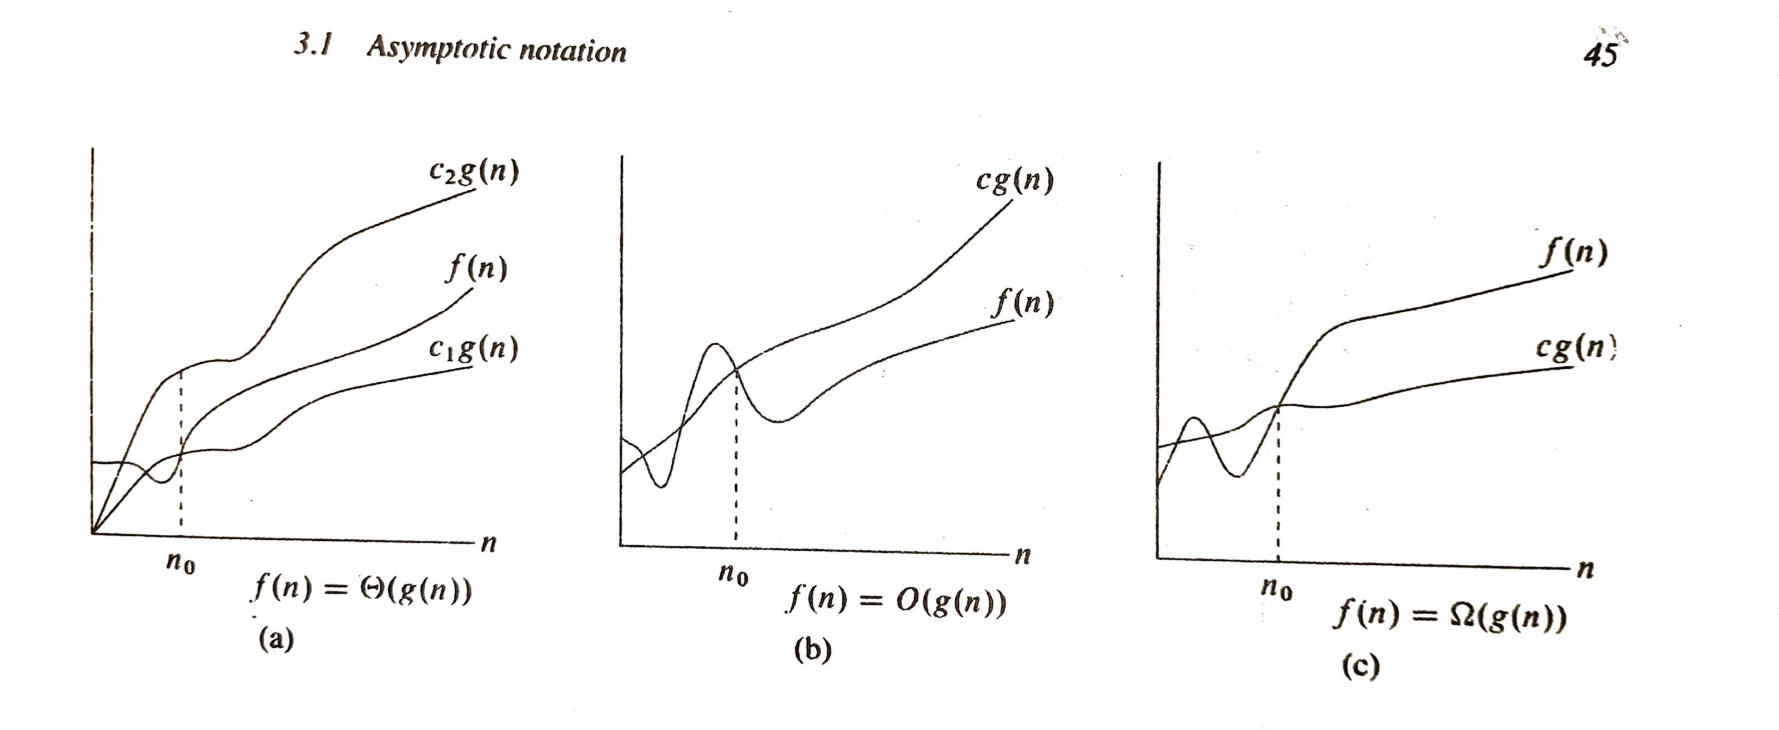

Ink Drawings
Ink Drawings
Ink Drawings
Ink Drawings
Ink Drawings
Ink Drawings
Ink Drawings
Ink Drawings
Ink Drawings
Ink Drawings
Ink Drawings
Ink Drawings
Ink Drawings
Ink Drawings
Ink Drawings
Ink Drawings
Ink Drawings
Ink Drawings
Ink Drawings
Ink Drawings
Ink Drawings
Ink Drawings
Ink Drawings
Ink Drawings
Ink Drawings
Ink Drawings
Ink Drawings
Ink Drawings
Ink Drawings
Ink Drawings
Ink Drawings
Ink Drawings
Ink Drawings
Ink Drawings
Ink Drawings
Ink Drawings
Ink Drawings
Ink Drawings
Ink Drawings
Ink Drawings
Ink Drawings
Ink Drawings
Ink Drawings
Ink Drawings
Ink Drawings
Ink Drawings
Ink Drawings
Ink Drawings
Ink Drawings
Ink Drawings
Ink Drawings
Ink Drawings
Ink Drawings
Ink Drawings
Ink Drawings
Ink Drawings
Ink Drawings
Ink Drawings
Ink Drawings
Ink Drawings
Ink Drawings
Ink Drawings
Ink Drawings
Ink Drawings
Ink Drawings
Ink Drawings
Ink Drawings
Ink Drawings
Ink Drawings
Ink Drawings
Ink Drawings
Ink Drawings
Ink Drawings
Ink Drawings
Ink Drawings
Ink Drawings
Ink Drawings
Ink Drawings
Ink Drawings
Ink Drawings


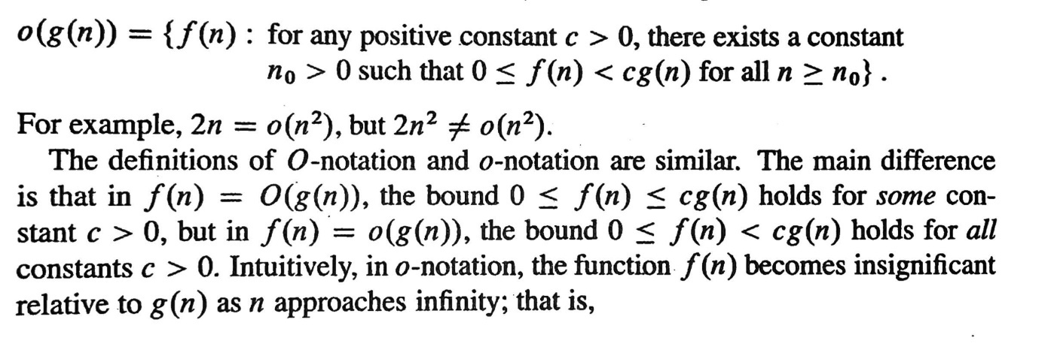

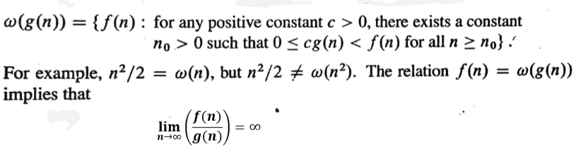**# Comparing Functions**

–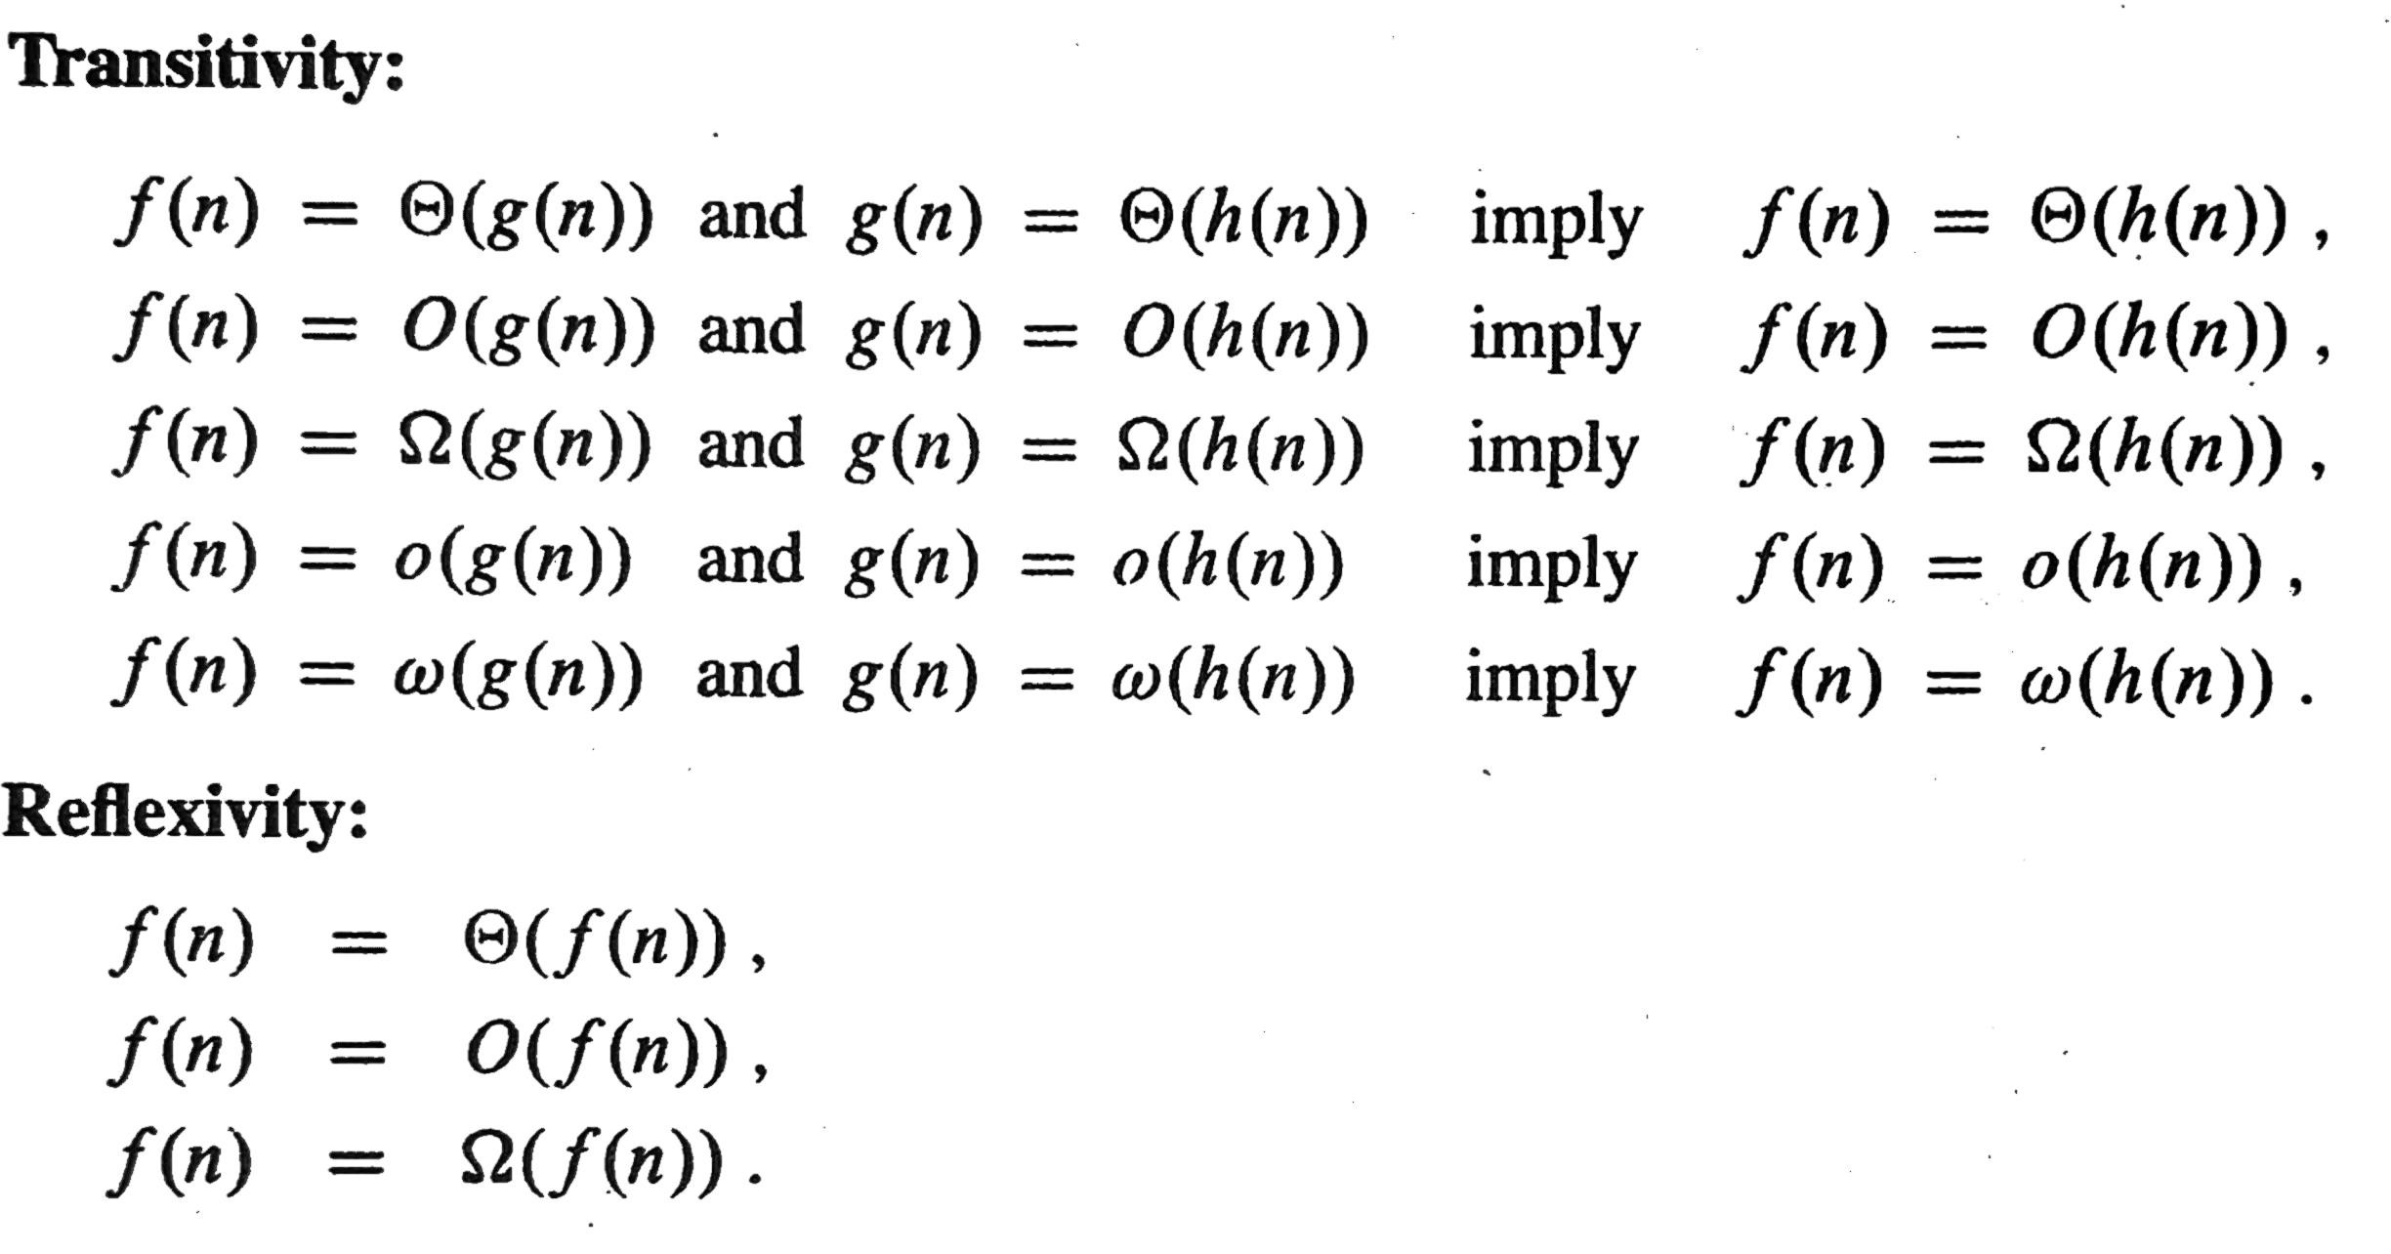

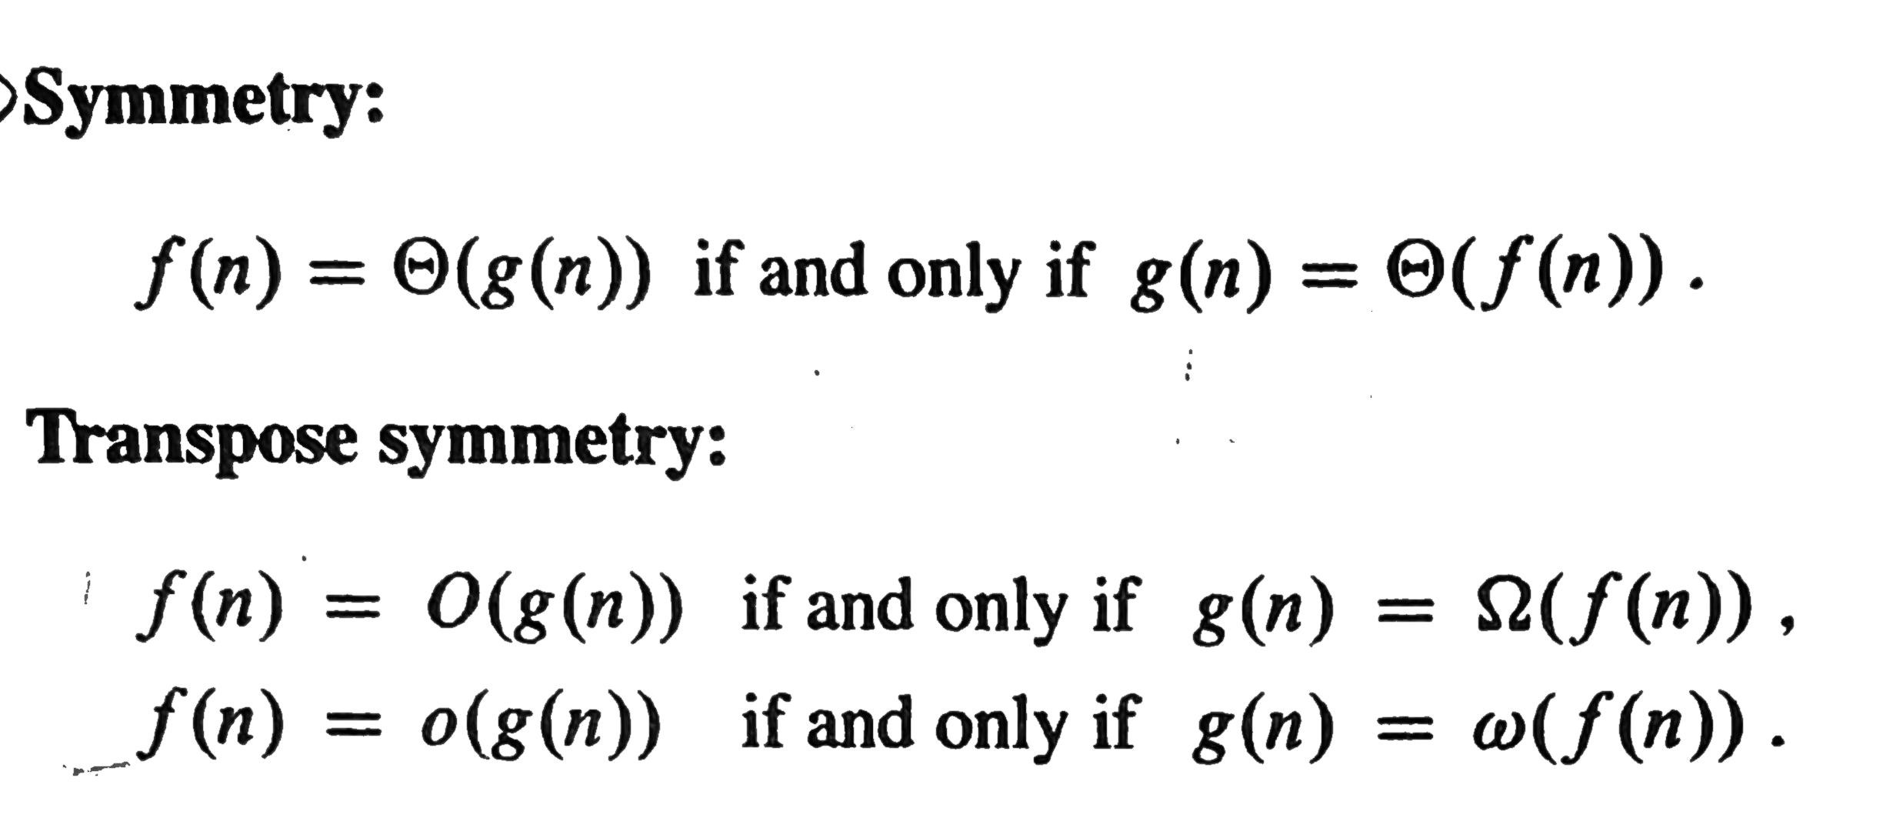

|  |  |  |  |  |
| --- | --- | --- | --- | --- |
|  | **Reflexive** | **Symmetric** | **Transitive** | **Transpose Symmetry** |
| **O** |  |  |  |  |
| **Ω** |  |  |  |  |
|  |  |  |  |  |
| **o** |  |  |  |  |
|  |  |  |  |  |

NOTE:- Transpose Symmetry is Important



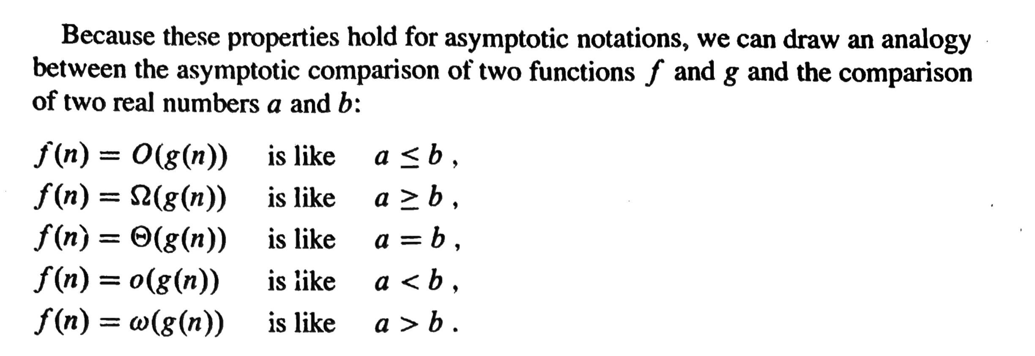

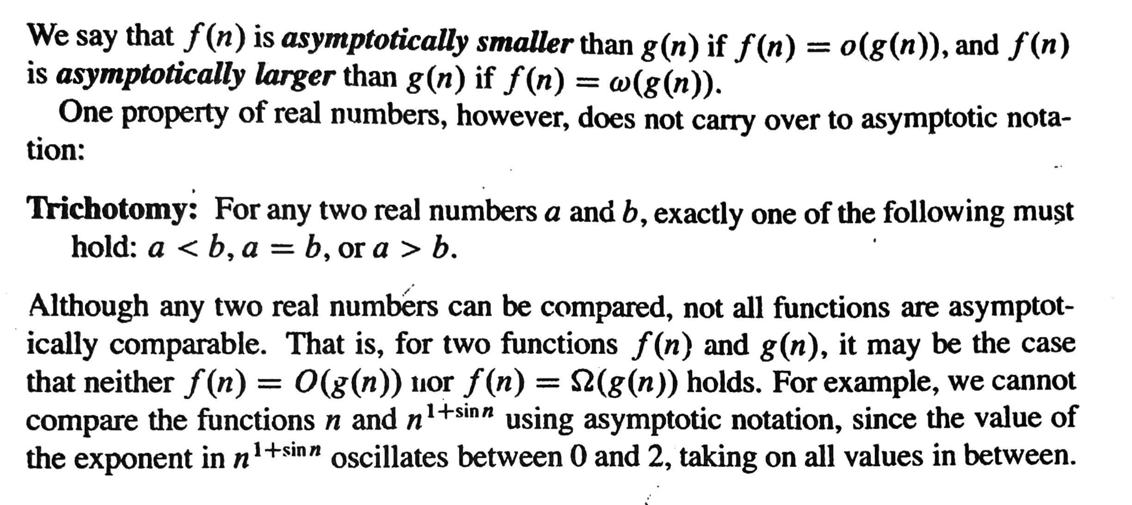

* **Look at this question to understand Trichotomy Property:-** [**https://gateoverflow.in/8501/gate-cse-2015-set-3-question-42**](https://gateoverflow.in/8501/gate-cse-2015-set-3-question-42)
* This Property has also been asked on IISC Interview

**3.1-7] (page 53)** Prove that ***o(g(n)) ∩ ω(g(n))*** is the empty set?

\* See page 18 and 19 for mathematical properties and geometric sum formula

* See gate 2023 question **‘’** is used instead of **‘= ‘.**

**Sorting**

1. **Bubble Sort: -**
   * Logic: - In every ith pass/iteration, place the ith max element at its correct position
   * It is INPLACE
   * Stale (Yes/No) \_\_\_\_\_\_\_\_\_\_
   * Every pass **(n-1) comparision**



|  |  |  |
| --- | --- | --- |
|  | **No. of Comparison** | **No. of Swaps** |
| **Best Case**  **(Increasing Order)** |  |  |
| **Worst Case**  **(Decreasing Order)** |  |  |



**Optimised Bubble Sort**: - If there are no swaps in any of the pass, then the array has got sorted already

1. **Selection Sort: -**
   * **Steps**
     + In the ith pass, find the index/position of the ith smallest element.
     + Swap it with the element that is present in the ith index.
     + Keep repeating until the array is sorted.
   * Inplace + Unstable
   * Always takes (n-1) passes
   * Every pass exactly 1 swap, so in total (n-1) swaps to get sorted
   * Among other Algorithm it takes least amount of swaps
2. **Insertion Sort: -**
   * **Idea** -> Take on element from sorted part and insert it to its correct position in sorted part.
   * **Insertion** -> It is achieved by swapping or updating the adjacent element
   * **Stable and Inplace**
   * **Best Case is when input is already sorted in required order. Every pass 1 Comparison and 0 Swaps**
   * There are always (n-1) passes always
   * Total (n-1) Comparison and 0 Swaps
   * Always takes (n-1) passes
   * T.C = O(n-1) = O(n)
   * **Worst Case is when input sorted in opposite order. T.C = O(n2)**
3. **Radix Sort: -**
   * **No. of Passes = No. of digit in Max element of given input**
   * **T.C = O(d \* (n+b)) = O(n\*d),** 
     + b = base of the given input
     + d = # digits in max element
     + n = # elements in given array
   * **Stable but not Inplace**

**Divide and Conquer**

Ink Drawings
Ink Drawings
Ink Drawings
Ink Drawings
Ink Drawings
Ink Drawings
Ink Drawings
Ink Drawings
Ink Drawings
Ink Drawings
Ink Drawings
Ink Drawings
Ink Drawings
Ink Drawings
Ink Drawings
Ink Drawings
Ink Drawings
Ink Drawings
Ink Drawings
Ink Drawings
Ink Drawings
Ink Drawings
Ink Drawings
Ink Drawings
Ink Drawings
Ink Drawings
Ink Drawings
Ink Drawings
Ink Drawings
Ink Drawings
Ink Drawings
Ink Drawings
Ink Drawings
Ink Drawings
Ink Drawings
Ink Drawings
Ink Drawings
Ink Drawings
Ink Drawings
Ink Drawings
Ink Drawings
Ink Drawings
Ink Drawings
Ink Drawings
Ink Drawings
Ink Drawings
Ink Drawings
Ink Drawings
Ink Drawings
Ink Drawings
Ink Drawings
Ink Drawings
Ink Drawings
Ink Drawings
Ink Drawings
Ink Drawings
Ink Drawings
Ink Drawings
Ink Drawings
Ink Drawings
Ink Drawings
Ink Drawings
Ink Drawings
Ink Drawings
Ink Drawings
Ink Drawings
Ink Drawings
Ink Drawings
Ink Drawings
Ink Drawings
Ink Drawings
Ink Drawings
Ink Drawings
Ink Drawings
Ink Drawings
Ink Drawings
Ink Drawings
Ink Drawings
Ink Drawings
Ink Drawings
Ink Drawings
Ink Drawings
Ink Drawings
Ink Drawings
Ink Drawings
Ink Drawings
Ink Drawings
Ink Drawings
Ink Drawings
Ink Drawings
Ink Drawings
Ink Drawings
Ink Drawings
Ink Drawings
Ink Drawings
Ink Drawings
Ink Drawings
Ink Drawings
Ink Drawings
Ink Drawings
Ink Drawings
Ink Drawings
Ink Drawings
Ink Drawings
Ink Drawings
Ink Drawings
Ink Drawings
Ink Drawings
Ink Drawings
Ink Drawings
Ink Drawings
Ink Drawings
Ink Drawings
Ink Drawings
Ink Drawings
Ink Drawings
Ink Drawings
Ink Drawings
Ink Drawings
Ink Drawings
Ink Drawings
Ink Drawings
Ink Drawings
Ink Drawings
Ink Drawings
Ink Drawings
Ink Drawings
Ink Drawings
Ink Drawings
Ink Drawings
Ink Drawings
Ink Drawings
Ink Drawings
Ink Drawings
Ink Drawings
Ink Drawings
Ink Drawings
Ink Drawings
Ink Drawings
Ink Drawings
Ink Drawings
Ink Drawings
Ink Drawings
Ink Drawings
Ink Drawings
Ink Drawings
Ink Drawings
Ink Drawings
Ink Drawings
Ink Drawings
Ink Drawings
Ink Drawings
Ink Drawings
Ink Drawings
Ink Drawings
Ink Drawings
Ink Drawings
Ink Drawings
Ink Drawings
Ink Drawings
Ink Drawings
Ink Drawings
Ink Drawings
Ink Drawings
Ink Drawings
Ink Drawings
Ink Drawings
Ink Drawings
Ink Drawings
Ink Drawings
Ink Drawings
Ink Drawings
Ink Drawings
Ink Drawings
Ink Drawings
Ink Drawings
Ink Drawings
Ink Drawings
Ink Drawings
Ink Drawings
Ink Drawings
Ink Drawings
Ink Drawings
Ink Drawings
Ink Drawings
Ink Drawings
Ink Drawings
Ink Drawings


Ink Drawings

If
Else if 
Total Comparisons
Best Case



Worst Case



Average Case



Ink Drawings
Ink Drawings
Ink Drawings
Ink Drawings
Ink Drawings
Ink Drawings
Ink Drawings
Ink Drawings
Ink Drawings
Ink Drawings
Ink Drawings
Ink Drawings
Ink Drawings
Ink Drawings
Ink Drawings
Ink Drawings
Ink Drawings
Ink Drawings
Ink Drawings
Ink Drawings
Ink Drawings
Ink Drawings
Ink Drawings
Ink Drawings
Ink Drawings
Ink Drawings
Ink Drawings
Ink Drawings
Ink Drawings
Ink Drawings
Ink Drawings
Ink Drawings
Ink Drawings
Ink Drawings
Ink Drawings
Ink Drawings
Ink Drawings
Ink Drawings
Ink Drawings
Ink Drawings
Ink Drawings
Ink Drawings
Ink Drawings
Ink Drawings
Ink Drawings
Ink Drawings
Ink Drawings
Ink Drawings
Ink Drawings
Ink Drawings
Ink Drawings
Ink Drawings
Ink Drawings
Ink Drawings
Ink Drawings
Ink Drawings
Ink Drawings
Ink Drawings
Ink Drawings
Min-Max Divide and Conquer Algorithm
Time Complexity analysis
Best Case:- Input in Decreasing Order (Only if condition get's executed
No. Of Comparisons:- (n-1)
Worst Case:- Input is in Increasing order
No. Of Comparisons:- 2*(n-1)
Average Case:- On Average, if condition get's executed half times
Time Complexity analysis
Best Case:- Input in Decreasing Order (Only if condition get's executed
No. Of Comparisons:- (n-1)
Worst Case:- Input is in Increasing order
No. Of Comparisons:- 2*(n-1)
Average Case:- On Average, if condition get's executed half times
Ink Drawings
Ink Drawings
Ink Drawings
Ink Drawings
Ink Drawings
Ink Drawings
Ink Drawings
Ink Drawings
Ink Drawings
Ink Drawings
Ink Drawings
Ink Drawings
Ink Drawings
Ink Drawings
Ink Drawings
Ink Drawings
Ink Drawings
Ink Drawings
Ink Drawings
T(n) = _____________________ , n = 1

T(n) = _____________________ , n = 2

T(n) = _____________________ , n > 2
Performance of Divide and Conquer based solution
Performance of Divide and Conquer based solution
Ink Drawings
Ink Drawings
Ink Drawings
Ink Drawings
Ink Drawings
Ink Drawings
Ink Drawings
Ink Drawings
Ink Drawings
Ink Drawings
Ink Drawings
Ink Drawings
Ink Drawings
Ink Drawings
Ink Drawings
Ink Drawings
Ink Drawings
Ink Drawings
Ink Drawings
Ink Drawings
Ink Drawings
Ink Drawings
Ink Drawings
Ink Drawings
Ink Drawings
Ink Drawings
Ink Drawings
Ink Drawings
Ink Drawings
Ink Drawings
Ink Drawings
Ink Drawings
Ink Drawings
Ink Drawings


Ink Drawings
Binary Search
Ink Drawings
Ink Drawings
Ink Drawings
Ink Drawings
Ink Drawings
Ink Drawings
Ink Drawings
Ink Drawings
Ink Drawings
Ink Drawings
Ink Drawings
Ink Drawings
Ink Drawings
Ink Drawings
Ink Drawings
Ink Drawings
Ink Drawings
Ink Drawings
Ink Drawings
Ink Drawings
Ink Drawings
Ink Drawings
Ink Drawings
Ink Drawings
Ink Drawings
Ink Drawings
Ink Drawings
Ink Drawings
Ink Drawings
Ink Drawings
Ink Drawings
Ink Drawings
Ink Drawings
Ink Drawings
Ink Drawings
Ink Drawings
Ink Drawings
Ink Drawings
Ink Drawings
Ink Drawings
Ink Drawings
Ink Drawings
Ink Drawings
Ink Drawings
Ink Drawings
Ink Drawings
Ink Drawings
Ink Drawings
Ink Drawings
Ink Drawings
Ink Drawings
Ink Drawings
Ink Drawings
Ink Drawings
Ink Drawings
Ink Drawings
Ink Drawings
Ink Drawings
Ink Drawings
Ink Drawings
Ink Drawings
Ink Drawings
Ink Drawings
Ink Drawings
Ink Drawings
Ink Drawings
Ink Drawings
Ink Drawings
Ink Drawings
Ink Drawings
Ink Drawings
Ink Drawings
Ink Drawings
Ink Drawings
Ink Drawings
Ink Drawings
Ink Drawings
Ink Drawings
Ink Drawings
Ink Drawings
Ink Drawings
Ink Drawings
Ink Drawings
Ink Drawings
Ink Drawings
Ink Drawings
Ink Drawings
Ink Drawings
Ink Drawings
Ink Drawings
Ink Drawings
Ink Drawings
Ink Drawings
Ink Drawings
Ink Drawings
Ink Drawings
Ink Drawings
Ink Drawings
Ink Drawings
Ink Drawings
Ink Drawings
Ink Drawings
Ink Drawings
Ink Drawings
Ink Drawings
Ink Drawings
Ink Drawings
Ink Drawings
Ink Drawings
Ink Drawings
Ink Drawings
Ink Drawings
Ink Drawings
Ink Drawings
Ink Drawings


Ink Drawings
Merge Sort
Problem Statement:- Given two sorted list/array L1 -> n1 and L2 -> n2 such that n1 ≤ n2 , Merge them into single sorted list/array.
Problem Statement:- Given two sorted list/array L1 -> n1 and L2 -> n2 such that n1 ≤ n2 , Merge them into single sorted list/array.
Ink Drawings
Ink Drawings
Ink Drawings
Ink Drawings
Ink Drawings
Ink Drawings
Ink Drawings
Ink Drawings
Ink Drawings
Ink Drawings
Ink Drawings
Ink Drawings
Ink Drawings
Ink Drawings
Ink Drawings
Ink Drawings
Ink Drawings
Ink Drawings
Ink Drawings
Ink Drawings
Ink Drawings
Ink Drawings
Ink Drawings
Ink Drawings
Ink Drawings
Ink Drawings
Ink Drawings
Ink Drawings
Ink Drawings
Ink Drawings
Ink Drawings
Ink Drawings
Ink Drawings
Ink Drawings
Ink Drawings
Ink Drawings
Ink Drawings
Ink Drawings
Ink Drawings
Ink Drawings
Ink Drawings
Ink Drawings
Ink Drawings
Ink Drawings
Ink Drawings
Ink Drawings
Ink Drawings
Ink Drawings
Ink Drawings
Ink Drawings
Ink Drawings
Ink Drawings
Ink Drawings
Ink Drawings
Ink Drawings
Ink Drawings
Ink Drawings
Ink Drawings
Ink Drawings
Ink Drawings
Ink Drawings
Ink Drawings
Ink Drawings
Ink Drawings
Ink Drawings
Ink Drawings
Ink Drawings
Ink Drawings
Ink Drawings
Ink Drawings
Ink Drawings
Ink Drawings
Ink Drawings
Ink Drawings
Ink Drawings
Ink Drawings
Ink Drawings
Ink Drawings
Ink Drawings
Ink Drawings
Ink Drawings
Ink Drawings
Ink Drawings
Ink Drawings
Ink Drawings
Ink Drawings
Ink Drawings
Ink Drawings
Ink Drawings
Ink Drawings
Ink Drawings
Ink Drawings
Ink Drawings
Ink Drawings
Ink Drawings
Ink Drawings
Ink Drawings
Ink Drawings
Ink Drawings
Ink Drawings
Ink Drawings
Ink Drawings
Ink Drawings
Ink Drawings
Ink Drawings
Ink Drawings
Ink Drawings
Ink Drawings
Ink Drawings
Ink Drawings
Ink Drawings
Ink Drawings
Ink Drawings
Ink Drawings
Ink Drawings
Ink Drawings
Ink Drawings
Ink Drawings
Ink Drawings
Ink Drawings
Ink Drawings
Ink Drawings
Ink Drawings
Ink Drawings
Ink Drawings
Ink Drawings
Ink Drawings
Ink Drawings
Ink Drawings
Ink Drawings
Ink Drawings
Ink Drawings
Ink Drawings
Ink Drawings
Ink Drawings
Ink Drawings
Ink Drawings
Ink Drawings
Ink Drawings
Ink Drawings
Ink Drawings
Ink Drawings
Ink Drawings
Ink Drawings
Ink Drawings
Ink Drawings
Ink Drawings
Ink Drawings
Ink Drawings
Ink Drawings
Ink Drawings
Ink Drawings
Ink Drawings
Ink Drawings
Ink Drawings
Ink Drawings
Ink Drawings
Ink Drawings
Ink Drawings


Ink Drawings
Quick Sort
The running time of Quick Sort depends on whether the partitioning is balanced or unbalanced, which in turn depends on which elements are used for partitioning
Insertion Sort  ≤  Quick Sort  ≤  Merge Sort

The running time of Quick Sort depends on whether the partitioning is balanced or unbalanced, which in turn depends on which elements are used for partitioning
Insertion Sort  ≤  Quick Sort  ≤  Merge Sort

W.C Partitioning ->  T﷐n-1﷯+𝜃﷐𝑛﷯= Ο(﷐𝑛﷮2﷯)
W.C Partitioning ->  T﷐n-1﷯+𝜃﷐𝑛﷯= Ο(﷐𝑛﷮2﷯)

B.C Partitioning   ->  2𝑇﷐﷐𝑛﷮2﷯﷯+ 𝜃﷐𝑛﷯= 𝜃(𝑛∗﷐log﷮𝑛﷯)
Running time of QS in W.C when 
all the elements are same: Ο(﷐𝑛﷮2﷯)
Array contain distinct elements and is sorted in decreasing order: Ο(﷐𝑛﷮2﷯)
Only Middle elements as Pivot: Ο(﷐𝑛﷮2﷯)
Median is always selected as Pivot: 𝜃(𝑛∗﷐log﷮𝑛﷯)
Running time of QS in W.C when 
all the elements are same: Ο(﷐𝑛﷮2﷯)
Array contain distinct elements and is sorted in decreasing order: Ο(﷐𝑛﷮2﷯)
Only Middle elements as Pivot: Ο(﷐𝑛﷮2﷯)
Median is always selected as Pivot: 𝜃(𝑛∗﷐log﷮𝑛﷯)


Ink Drawings
Matrix Multiplication
Recurrence for Divide and Conquer based
T(n) = c      ; n ≤ 2
T(n) = 8𝑇﷐﷐𝑛﷮2﷯﷯+𝑏∗﷐𝑛﷮2﷯ ;𝑛>2, 𝑏>2

        = Ο﷐﷐𝑛﷮3﷯﷯

Recurrence for Divide and Conquer based
T(n) = c      ; n ≤ 2
T(n) = 8𝑇﷐﷐𝑛﷮2﷯﷯+𝑏∗﷐𝑛﷮2﷯ ;𝑛>2, 𝑏>2

        = Ο﷐﷐𝑛﷮3﷯﷯

SC = Ο(﷐log﷮𝑛﷯)

SC = Ο(﷐log﷮𝑛﷯)

Recurrence for Stressen's Matrix Multiplication
T(n) = c      ; n ≤ 2
T(n) = 7𝑇﷐﷐𝑛﷮2﷯﷯+𝑏∗﷐𝑛﷮2﷯ ;𝑛>2, 𝑏>2

        = Ο﷐﷐𝑛﷮2.81﷯﷯

Recurrence for Stressen's Matrix Multiplication
T(n) = c      ; n ≤ 2
T(n) = 7𝑇﷐﷐𝑛﷮2﷯﷯+𝑏∗﷐𝑛﷮2﷯ ;𝑛>2, 𝑏>2

        = Ο﷐﷐𝑛﷮2.81﷯﷯

SC = Ο﷐﷐𝑛﷮2﷯+﷐log﷮𝑛﷯﷯= Ο(﷐𝑛﷮2﷯)
SC = Ο﷐﷐𝑛﷮2﷯+﷐log﷮𝑛﷯﷯= Ο(﷐𝑛﷮2﷯)


Ink Drawings
Master's Theorem
Only applicable for:- 
Only applicable for:- 

𝑻﷐𝒏﷯=𝒂∗𝑻﷐﷐𝒏﷮𝒃﷯﷯+𝒇﷐𝒏﷯

Such the a ≥ 1, b > 1, 𝑓﷐𝑛﷯ is a Positive function
Case 1:- 
Case 1:- 
If f(n) is 𝚶﷐﷐𝒏﷮﷐﷐﷐𝐥𝐨𝐠﷮𝒃﷯﷮𝒂 − 𝜺﷯﷯﷯﷯ then

T(n) = 𝜽﷐﷐𝒏﷮﷐﷐𝐥𝐨𝐠﷮𝒃﷯﷮𝒂﷯﷯﷯
Ink Drawings
Case 2:-
Case 2:-
If f(n) is 𝜽﷐﷐𝒏﷮﷐﷐𝐥𝐨𝐠﷮𝒃﷯﷮𝒂﷯﷯∗ ﷐﷐﷐𝐥𝐨𝐠﷮𝒏﷯﷯﷮𝒌﷯﷯ for some k, Such that
(a) k ≥ 0, then

T(n) = 𝜽﷐﷐𝒏﷮﷐﷐𝐥𝐨𝐠﷮𝒃﷯﷮𝒂﷯﷯∗ ﷐﷐﷐𝐥𝐨𝐠﷮𝒏﷯﷯﷮﷐𝒌+𝟏﷯﷯﷯

(b) k = -1, then

T(n) = 𝜽﷐﷐𝒏﷮﷐﷐𝐥𝐨𝐠﷮𝒃﷯﷮𝒂﷯﷯∗﷐𝐥𝐨𝐠﷮﷐𝐥𝐨𝐠﷮𝒏﷯﷯﷯

Case 3:-
Case 3:-
If f(n) is 𝛀﷐﷐𝒏﷮﷐﷐﷐𝐥𝐨𝐠﷮𝒃﷯﷮𝒂﷯+ 𝜺﷯﷯﷯ for some 𝜺 > 0 AND
𝒂∗𝒇﷐𝒏﷯≤  𝜹∗𝒇﷐𝒏﷯ for some 𝜹 < 1 then

T(n) = 𝜽﷐𝒇(𝒏)﷯
Ink Drawings
Ink Drawings
Ink Drawings
Ink Drawings


1. **Revision Through PYQ’s**

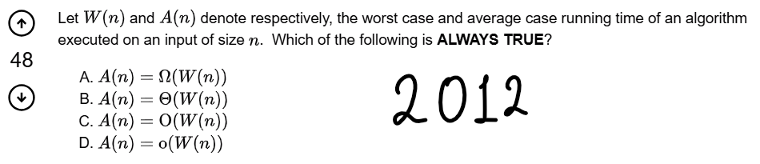

<https://gateoverflow.in/50/gate-cse-2012-question-18>

Ink Drawings
Ink Drawings
Ink Drawings
Ink Drawings
Ink Drawings
Ink Drawings
Ink Drawings
Ink Drawings
Ink Drawings
Ink Drawings
Ink Drawings
Ink Drawings
Ink Drawings
Ink Drawings
Ink Drawings
Ink Drawings
Ink Drawings
Ink Drawings
Ink Drawings
Ink Drawings
Ink Drawings
Ink Drawings
Ink Drawings
Ink Drawings
Ink Drawings
Ink Drawings
Ink Drawings
Ink Drawings
Ink Drawings
Ink Drawings
Ink Drawings
Ink Drawings
Ink Drawings
Ink Drawings
Ink Drawings
Ink Drawings
Ink Drawings
Ink Drawings
Ink Drawings
Ink Drawings
Ink Drawings
Ink Drawings
Ink Drawings
Ink Drawings
Ink Drawings
Ink Drawings
Ink Drawings
Ink Drawings
Ink Drawings
Ink Drawings
Ink Drawings
Ink Drawings
Ink Drawings
Ink Drawings
Ink Drawings
Ink Drawings
Ink Drawings
Ink Drawings
Ink Drawings
Ink Drawings
Ink Drawings
Ink Drawings
Ink Drawings
Ink Drawings
Ink Drawings
Ink Drawings
Ink Drawings
Ink Drawings
Ink Drawings
Ink Drawings
Ink Drawings
Ink Drawings
Ink Drawings
Ink Drawings
Ink Drawings
Ink Drawings
Ink Drawings
Ink Drawings
Ink Drawings
Ink Drawings


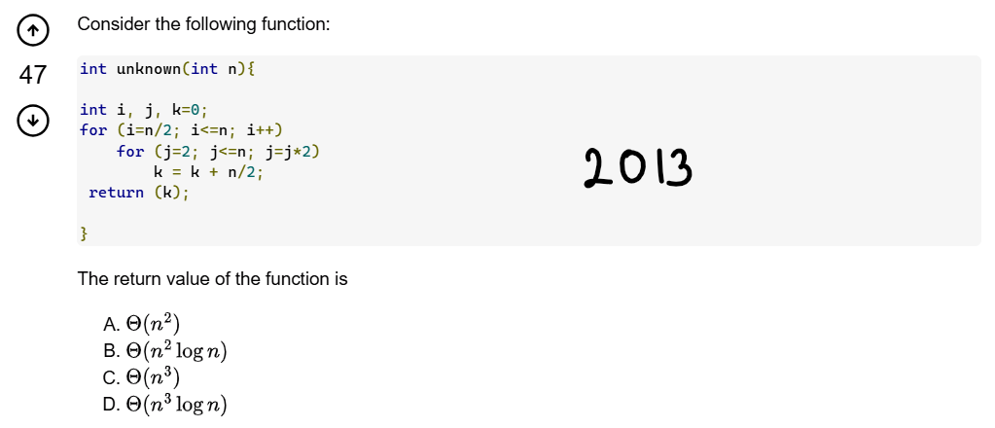

<https://gateoverflow.in/1542/gate-cse-2013-question-31>

Ink Drawings
Ink Drawings
Ink Drawings
Ink Drawings
Ink Drawings
Ink Drawings
Ink Drawings
Ink Drawings
Ink Drawings
Ink Drawings
Ink Drawings
Ink Drawings
Ink Drawings
Ink Drawings
Ink Drawings
Ink Drawings
Ink Drawings
Ink Drawings
Ink Drawings
Ink Drawings
Ink Drawings
Ink Drawings
Ink Drawings
Ink Drawings
Ink Drawings
Ink Drawings
Ink Drawings
Ink Drawings
Ink Drawings
Ink Drawings
Ink Drawings
Ink Drawings
Ink Drawings
Ink Drawings
Ink Drawings
Ink Drawings
Ink Drawings
Ink Drawings
Ink Drawings
Ink Drawings
Ink Drawings
Ink Drawings
Ink Drawings
Ink Drawings
Ink Drawings
Ink Drawings
Ink Drawings
Ink Drawings
Ink Drawings
Ink Drawings
Ink Drawings
Ink Drawings
Ink Drawings
Ink Drawings
Ink Drawings
Ink Drawings
Ink Drawings
Ink Drawings
Ink Drawings
Ink Drawings
Ink Drawings
Ink Drawings
Ink Drawings
Ink Drawings
Ink Drawings
Ink Drawings
Ink Drawings
Ink Drawings
Ink Drawings
Ink Drawings


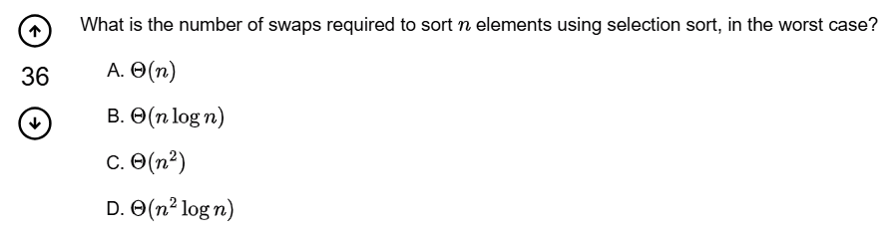



<https://gateoverflow.in/1303/gate-cse-2009-question-11>

* Find for several other sorting algorithm.

Ink Drawings
Ink Drawings
Ink Drawings
Ink Drawings
Ink Drawings
Ink Drawings
Ink Drawings
Ink Drawings
Ink Drawings
Ink Drawings
Ink Drawings
Ink Drawings
Ink Drawings
Ink Drawings
Ink Drawings
Ink Drawings
Ink Drawings
Ink Drawings
Ink Drawings
Ink Drawings
Ink Drawings
Ink Drawings
Ink Drawings
Ink Drawings
Ink Drawings
Ink Drawings
Ink Drawings
Ink Drawings
Ink Drawings
Ink Drawings
Ink Drawings
Ink Drawings
Ink Drawings
Ink Drawings
Ink Drawings
Ink Drawings
Ink Drawings
Ink Drawings
Ink Drawings
Ink Drawings
Ink Drawings
Ink Drawings
Ink Drawings
Ink Drawings
Ink Drawings
Ink Drawings
Ink Drawings
Ink Drawings
Ink Drawings
Ink Drawings
Ink Drawings
Ink Drawings
Ink Drawings
Ink Drawings
Ink Drawings
Ink Drawings
Ink Drawings
Ink Drawings
Ink Drawings
Ink Drawings
Ink Drawings
Ink Drawings
Ink Drawings
Ink Drawings
Ink Drawings
Ink Drawings
Ink Drawings
Ink Drawings
Ink Drawings
Ink Drawings
Ink Drawings
Ink Drawings
Ink Drawings
Ink Drawings
Ink Drawings
Ink Drawings


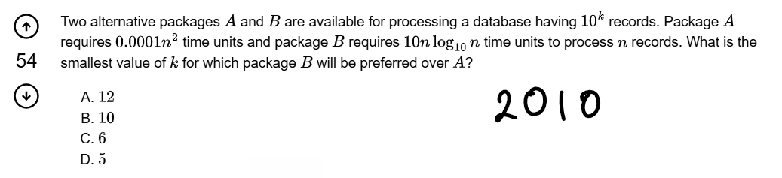

<https://gateoverflow.in/2185/gate-cse-2010-question-12>

Ink Drawings
Ink Drawings
Ink Drawings
Ink Drawings
Ink Drawings
Ink Drawings
Ink Drawings
Ink Drawings
Ink Drawings
Ink Drawings
Ink Drawings
Ink Drawings
Ink Drawings
Ink Drawings
Ink Drawings
Ink Drawings
Ink Drawings
Ink Drawings
Ink Drawings
Ink Drawings
Ink Drawings
Ink Drawings
Ink Drawings
Ink Drawings
Ink Drawings
Ink Drawings
Ink Drawings
Ink Drawings
Ink Drawings
Ink Drawings
Ink Drawings
Ink Drawings
Ink Drawings
Ink Drawings
Ink Drawings
Ink Drawings
Ink Drawings
Ink Drawings
Ink Drawings
Ink Drawings
Ink Drawings
Ink Drawings
Ink Drawings
Ink Drawings
Ink Drawings
Ink Drawings
Ink Drawings
Ink Drawings
Ink Drawings
Ink Drawings
Ink Drawings
Ink Drawings
Ink Drawings
Ink Drawings
Ink Drawings
Ink Drawings
Ink Drawings
Ink Drawings
Ink Drawings
Ink Drawings
Ink Drawings
Ink Drawings
Ink Drawings
Ink Drawings
Ink Drawings
Ink Drawings
Ink Drawings
Ink Drawings
Ink Drawings
Ink Drawings
Ink Drawings
Ink Drawings
Ink Drawings
Ink Drawings
Ink Drawings
Ink Drawings
Ink Drawings
Ink Drawings
Ink Drawings
Ink Drawings
Ink Drawings
Ink Drawings
Ink Drawings
Ink Drawings
Ink Drawings
Ink Drawings
Ink Drawings
Ink Drawings
Ink Drawings
Ink Drawings
Ink Drawings
Ink Drawings
Ink Drawings
Ink Drawings
Ink Drawings
Ink Drawings
Ink Drawings
Ink Drawings
Ink Drawings
Ink Drawings
Ink Drawings
Ink Drawings
Ink Drawings
Ink Drawings
Ink Drawings
Ink Drawings
Ink Drawings
Ink Drawings
Ink Drawings
Ink Drawings
Ink Drawings
Ink Drawings
Ink Drawings
Ink Drawings
Ink Drawings
Ink Drawings
Ink Drawings
Ink Drawings
Ink Drawings
Ink Drawings
Ink Drawings
Ink Drawings
Ink Drawings
Ink Drawings
Ink Drawings
Ink Drawings
Ink Drawings
Ink Drawings
Ink Drawings
Ink Drawings
Ink Drawings
Ink Drawings
Ink Drawings
Ink Drawings
Ink Drawings
Ink Drawings
Ink Drawings
Ink Drawings
Ink Drawings
Ink Drawings
Ink Drawings
Ink Drawings
Ink Drawings
Ink Drawings
Ink Drawings
Ink Drawings
Ink Drawings
Ink Drawings
Ink Drawings
Ink Drawings
Ink Drawings
Ink Drawings
Ink Drawings
Ink Drawings
Ink Drawings
Ink Drawings
Ink Drawings
Ink Drawings
Ink Drawings
Ink Drawings
Ink Drawings
Ink Drawings
Ink Drawings
Ink Drawings
Ink Drawings
Ink Drawings
Ink Drawings
Ink Drawings
Ink Drawings
Ink Drawings
Ink Drawings
Ink Drawings
Ink Drawings
Ink Drawings
Ink Drawings
Ink Drawings
Ink Drawings
Ink Drawings
Ink Drawings
Ink Drawings
Ink Drawings
Ink Drawings
Ink Drawings
Ink Drawings
Ink Drawings
Ink Drawings
Ink Drawings
Ink Drawings
Ink Drawings
Ink Drawings
Ink Drawings
Ink Drawings
Ink Drawings
Ink Drawings
Ink Drawings
Ink Drawings
Ink Drawings
Ink Drawings
Ink Drawings
Ink Drawings
Ink Drawings
Ink Drawings
Ink Drawings
Ink Drawings
Ink Drawings
Ink Drawings




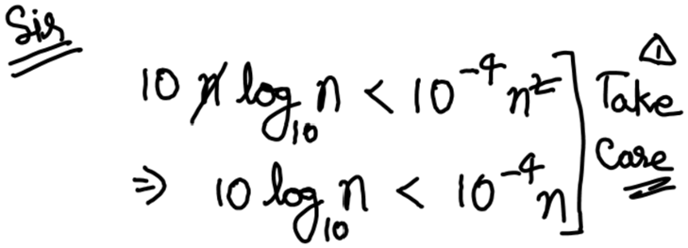



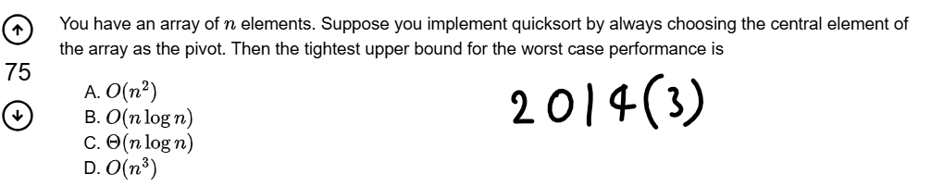

<https://gateoverflow.in/2048/gate-cse-2014-set-3-question-14>

Ink Drawings
Ink Drawings
Ink Drawings
Ink Drawings
Ink Drawings
Ink Drawings
Ink Drawings
Ink Drawings
Ink Drawings
Ink Drawings
Ink Drawings
Ink Drawings
Ink Drawings
Ink Drawings
Ink Drawings
Ink Drawings
Ink Drawings
Ink Drawings
Ink Drawings
Ink Drawings
Ink Drawings
Ink Drawings
Ink Drawings
Ink Drawings
Ink Drawings
Ink Drawings
Ink Drawings
Ink Drawings
Ink Drawings
Ink Drawings
Ink Drawings
Ink Drawings
Ink Drawings
Ink Drawings
Ink Drawings
Ink Drawings
Ink Drawings
Ink Drawings
Ink Drawings
Ink Drawings
Ink Drawings
Ink Drawings
Ink Drawings
Ink Drawings
Ink Drawings
Ink Drawings
Ink Drawings
Ink Drawings
Ink Drawings
Ink Drawings
Ink Drawings
Ink Drawings
Ink Drawings
Ink Drawings
Ink Drawings
Ink Drawings
Ink Drawings
Ink Drawings
Ink Drawings
Ink Drawings
Ink Drawings
Ink Drawings
Ink Drawings
Ink Drawings
Ink Drawings


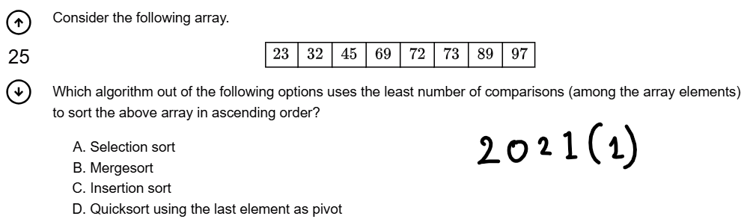

<https://gateoverflow.in/357443/gate-cse-2021-set-1-question-9>

* Table of No. of Comparisons of all sorting algorithm

Ink Drawings
Ink Drawings
Ink Drawings
Ink Drawings
Ink Drawings
Ink Drawings
Ink Drawings
Ink Drawings
Ink Drawings
Ink Drawings
Ink Drawings
Ink Drawings
Ink Drawings
Ink Drawings
Ink Drawings
Ink Drawings
Ink Drawings
Ink Drawings
Ink Drawings
Ink Drawings
Ink Drawings
Ink Drawings
Ink Drawings
Ink Drawings
Ink Drawings
Ink Drawings
Ink Drawings
Ink Drawings
Ink Drawings
Ink Drawings
Ink Drawings
Ink Drawings
Ink Drawings
Ink Drawings
Ink Drawings
Ink Drawings
Ink Drawings
Ink Drawings
Ink Drawings
Ink Drawings
Ink Drawings
Ink Drawings
Ink Drawings
Ink Drawings
Ink Drawings
Ink Drawings
Ink Drawings
Ink Drawings
Ink Drawings
Ink Drawings
Ink Drawings
Ink Drawings
Ink Drawings
Ink Drawings
Ink Drawings
Ink Drawings
Ink Drawings
Ink Drawings
Ink Drawings
Ink Drawings
Ink Drawings
Ink Drawings
Ink Drawings
Ink Drawings
Ink Drawings
Ink Drawings
Ink Drawings
Ink Drawings
Ink Drawings
Ink Drawings
Ink Drawings


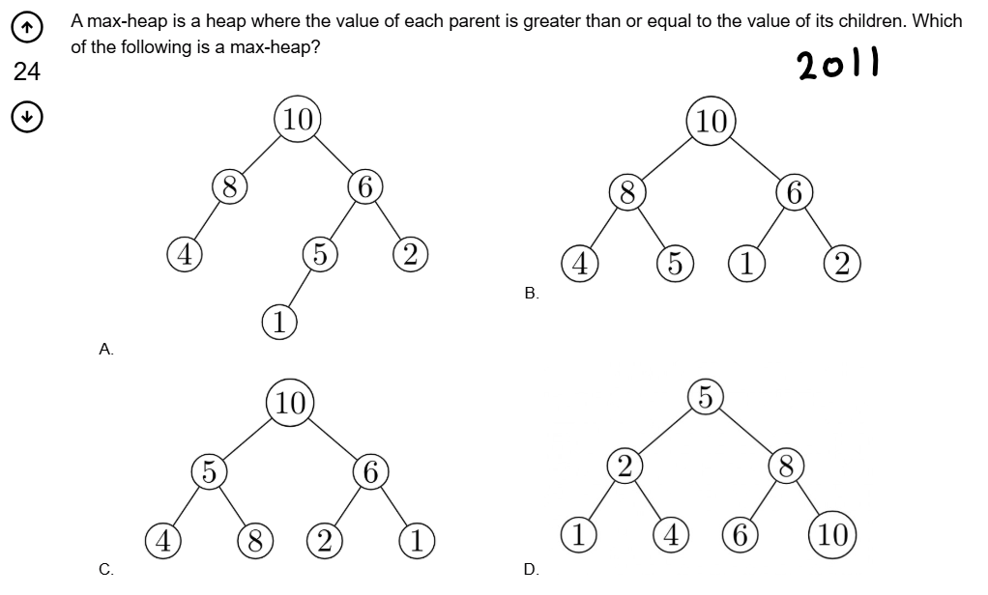

<https://gateoverflow.in/2125/gate-cse-2011-question-23>

* (a) is not a CBT
* Hence (b) is the correct answer

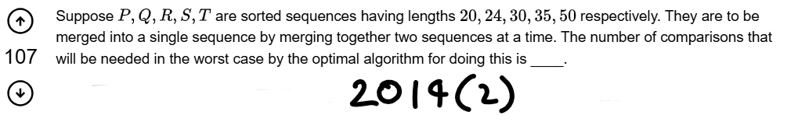

<https://gateoverflow.in/1997/gate-cse-2014-set-2-question-38>

* Pick them in **SHORTED ORDER ONLY**

Ink Drawings
Ink Drawings
Ink Drawings
Ink Drawings
Ink Drawings
Ink Drawings
Ink Drawings
Ink Drawings
Ink Drawings
Ink Drawings
Ink Drawings
Ink Drawings
Ink Drawings
Ink Drawings
Ink Drawings
Ink Drawings
Ink Drawings
Ink Drawings
Ink Drawings
Ink Drawings
Ink Drawings
Ink Drawings
Ink Drawings
Ink Drawings
Ink Drawings
Ink Drawings
Ink Drawings
Ink Drawings
Ink Drawings
Ink Drawings
Ink Drawings
Ink Drawings
Ink Drawings
Ink Drawings
Ink Drawings
Ink Drawings
Ink Drawings
Ink Drawings
Ink Drawings
Ink Drawings
Ink Drawings
Ink Drawings
Ink Drawings
Ink Drawings
Ink Drawings
Ink Drawings
Ink Drawings
Ink Drawings
Ink Drawings
Ink Drawings
Ink Drawings
Ink Drawings
Ink Drawings
Ink Drawings
Ink Drawings
Ink Drawings
Ink Drawings
Ink Drawings
Ink Drawings
Ink Drawings
Ink Drawings
Ink Drawings
Ink Drawings
Ink Drawings
Ink Drawings
Ink Drawings
Ink Drawings
Ink Drawings
Ink Drawings
Ink Drawings
Ink Drawings
Ink Drawings
Ink Drawings
Ink Drawings
Ink Drawings
Ink Drawings
Ink Drawings
Ink Drawings
Ink Drawings
Ink Drawings
Ink Drawings
Ink Drawings
Ink Drawings
Ink Drawings
Ink Drawings
Ink Drawings
Ink Drawings
Ink Drawings
Ink Drawings
Ink Drawings
Ink Drawings
Ink Drawings
Ink Drawings
Ink Drawings
Ink Drawings
Ink Drawings
Ink Drawings
Ink Drawings
Ink Drawings
Ink Drawings
Ink Drawings
Ink Drawings
Ink Drawings
Ink Drawings
Ink Drawings
Ink Drawings
Ink Drawings


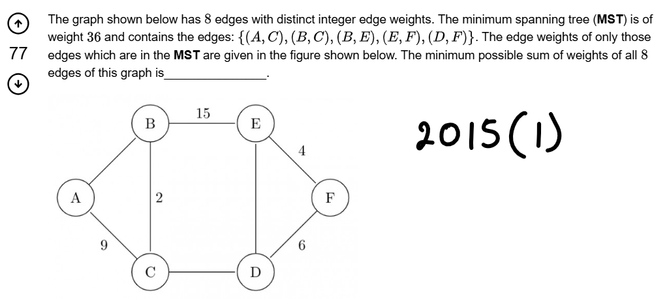



<https://gateoverflow.in/8313/gate-cse-2015-set-1-question-43>

* **Read Information Carefully** 
  + **Distinct integer edge weights:- earlier my answer was 66(9 + 15 + 6)**

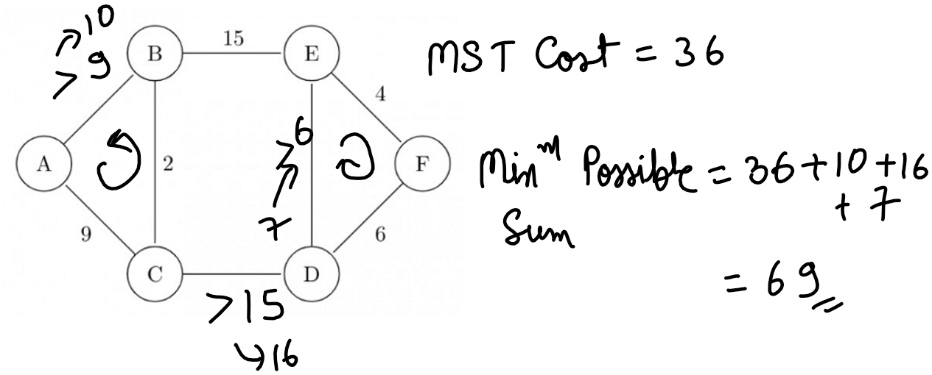

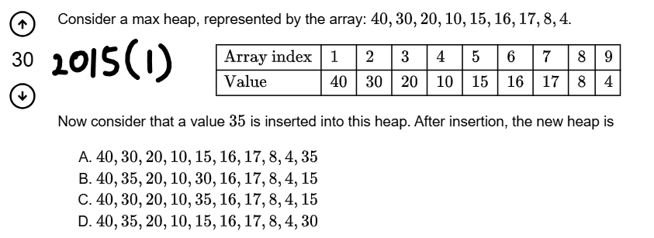

<https://gateoverflow.in/8273/gate-cse-2015-set-1-question-32>

Ink Drawings
Ink Drawings
Ink Drawings
Ink Drawings
Ink Drawings
Ink Drawings
Ink Drawings
Ink Drawings
Ink Drawings
Ink Drawings
Ink Drawings
Ink Drawings
Ink Drawings
Ink Drawings
Ink Drawings
Ink Drawings
Ink Drawings
Ink Drawings
Ink Drawings
Ink Drawings
Ink Drawings
Ink Drawings
Ink Drawings
Ink Drawings
Ink Drawings
Ink Drawings
Ink Drawings
Ink Drawings
Ink Drawings
Ink Drawings
Ink Drawings
Ink Drawings
Ink Drawings
Ink Drawings
Ink Drawings
Ink Drawings
Ink Drawings
Ink Drawings
Ink Drawings
Ink Drawings
Ink Drawings
Ink Drawings
Ink Drawings
Ink Drawings
Ink Drawings
Ink Drawings
Ink Drawings
Ink Drawings
Ink Drawings
Ink Drawings
Ink Drawings
Ink Drawings
Ink Drawings
Ink Drawings
Ink Drawings
Ink Drawings
Ink Drawings
Ink Drawings
Ink Drawings
Ink Drawings
Ink Drawings
Ink Drawings
Ink Drawings
Ink Drawings
Ink Drawings
Ink Drawings
Ink Drawings
Ink Drawings
Ink Drawings
Ink Drawings
Ink Drawings
Ink Drawings
Ink Drawings
Ink Drawings
Ink Drawings
Ink Drawings
Ink Drawings
Ink Drawings
Ink Drawings
Ink Drawings
Ink Drawings
Ink Drawings
Ink Drawings
Ink Drawings
Ink Drawings
Ink Drawings
Ink Drawings
Ink Drawings
Ink Drawings
Ink Drawings
Ink Drawings
Ink Drawings
Ink Drawings
Ink Drawings
Ink Drawings
Ink Drawings
Ink Drawings
Ink Drawings
Ink Drawings
Ink Drawings
Ink Drawings
Ink Drawings
Ink Drawings
Ink Drawings
Ink Drawings
Ink Drawings
Ink Drawings
Ink Drawings
Ink Drawings
Ink Drawings
Ink Drawings
Ink Drawings
Ink Drawings
Ink Drawings
Ink Drawings
Ink Drawings
Ink Drawings
Ink Drawings
Ink Drawings
Ink Drawings
Ink Drawings
Ink Drawings
Ink Drawings
Ink Drawings
Ink Drawings
Ink Drawings
Ink Drawings
Ink Drawings
Ink Drawings
Ink Drawings
Ink Drawings
Ink Drawings
Ink Drawings
Ink Drawings


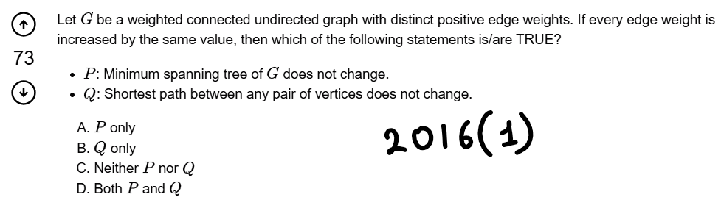

<https://gateoverflow.in/39673/gate-cse-2016-set-1-question-14>

Ink Drawings
Ink Drawings
Ink Drawings
Ink Drawings
Ink Drawings
Ink Drawings
Ink Drawings
Ink Drawings
Ink Drawings
Ink Drawings
Ink Drawings
Ink Drawings
Ink Drawings
Ink Drawings
Ink Drawings
Ink Drawings
Ink Drawings
Ink Drawings
Ink Drawings
Ink Drawings
Ink Drawings
Ink Drawings
Ink Drawings
Ink Drawings
Ink Drawings
Ink Drawings
Ink Drawings
Ink Drawings
Ink Drawings
Ink Drawings
Ink Drawings
Ink Drawings
Ink Drawings
Ink Drawings
Ink Drawings
Ink Drawings
Ink Drawings
Ink Drawings
Ink Drawings
Ink Drawings
Ink Drawings
Ink Drawings
Ink Drawings
Ink Drawings
Ink Drawings
Ink Drawings
Ink Drawings
Ink Drawings
Ink Drawings
Ink Drawings
Ink Drawings
Ink Drawings
Ink Drawings
Ink Drawings
Ink Drawings
Ink Drawings
Ink Drawings
Ink Drawings
Ink Drawings
Ink Drawings
Ink Drawings
Ink Drawings
Ink Drawings
Ink Drawings
Ink Drawings
Ink Drawings
Ink Drawings
Ink Drawings
Ink Drawings
Ink Drawings
Ink Drawings
Ink Drawings
Ink Drawings
Ink Drawings
Ink Drawings
Ink Drawings
Ink Drawings
Ink Drawings
Ink Drawings
Ink Drawings
Ink Drawings
Ink Drawings
Ink Drawings
Ink Drawings
Ink Drawings
Ink Drawings
Ink Drawings
Ink Drawings
Ink Drawings
Ink Drawings
Ink Drawings
Ink Drawings
Ink Drawings
Ink Drawings
Ink Drawings
Ink Drawings
Ink Drawings
Ink Drawings
Ink Drawings
Ink Drawings
Ink Drawings
Ink Drawings
Ink Drawings
Ink Drawings
Ink Drawings
Ink Drawings
Ink Drawings
Ink Drawings
Ink Drawings
Ink Drawings
Ink Drawings
Ink Drawings
Ink Drawings
Ink Drawings
Ink Drawings
Ink Drawings
Ink Drawings
Ink Drawings
Ink Drawings
Ink Drawings
Ink Drawings
Ink Drawings
Ink Drawings
Ink Drawings
Ink Drawings
Ink Drawings
Ink Drawings
Ink Drawings
Ink Drawings
Ink Drawings
Ink Drawings
Ink Drawings
Ink Drawings
Ink Drawings
Ink Drawings
Ink Drawings
Ink Drawings


* **Tricks:**
  + Come up with ONE example to contradict this fact

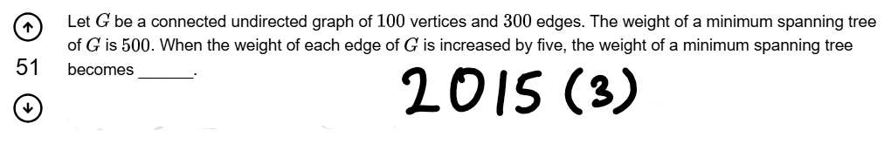

<https://gateoverflow.in/8499/gate-cse-2015-set-3-question-40>

Ink Drawings
Ink Drawings
Ink Drawings
Ink Drawings
Ink Drawings
Ink Drawings
Ink Drawings
Ink Drawings
Ink Drawings
Ink Drawings
Ink Drawings
Ink Drawings
Ink Drawings
Ink Drawings
Ink Drawings
Ink Drawings
Ink Drawings
Ink Drawings
Ink Drawings
Ink Drawings
Ink Drawings
Ink Drawings
Ink Drawings
Ink Drawings
Ink Drawings
Ink Drawings
Ink Drawings
Ink Drawings
Ink Drawings
Ink Drawings
Ink Drawings
Ink Drawings
Ink Drawings
Ink Drawings
Ink Drawings
Ink Drawings
Ink Drawings
Ink Drawings
Ink Drawings
Ink Drawings
Ink Drawings
Ink Drawings
Ink Drawings
Ink Drawings
Ink Drawings
Ink Drawings
Ink Drawings
Ink Drawings
Ink Drawings
Ink Drawings
Ink Drawings
Ink Drawings
Ink Drawings
Ink Drawings
Ink Drawings
Ink Drawings
Ink Drawings
Ink Drawings
Ink Drawings
Ink Drawings
Ink Drawings
Ink Drawings
Ink Drawings
Ink Drawings
Ink Drawings
Ink Drawings
Ink Drawings
Ink Drawings
Ink Drawings
Ink Drawings
Ink Drawings
Ink Drawings
Ink Drawings
Ink Drawings
Ink Drawings
Ink Drawings
Ink Drawings
Ink Drawings
Ink Drawings
Ink Drawings
Ink Drawings
Ink Drawings
Ink Drawings
Ink Drawings
Ink Drawings
Ink Drawings
Ink Drawings
Ink Drawings
Ink Drawings
Ink Drawings
Ink Drawings
Ink Drawings
Ink Drawings
Ink Drawings
Ink Drawings
Ink Drawings
Ink Drawings
Ink Drawings
Ink Drawings
Ink Drawings
Ink Drawings
Ink Drawings


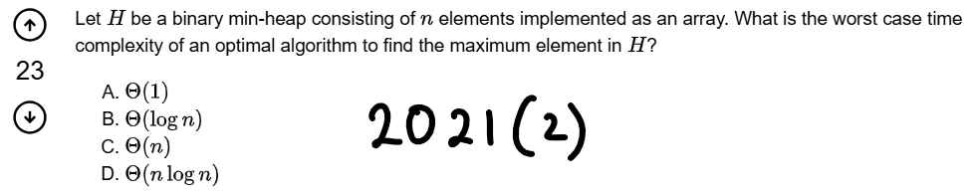

<https://gateoverflow.in/357538/gate-cse-2021-set-2-question-2>

Ink Drawings
Ink Drawings
Ink Drawings
Ink Drawings
Ink Drawings
Ink Drawings
Ink Drawings
Ink Drawings
Ink Drawings
Ink Drawings
Ink Drawings
Ink Drawings
Ink Drawings
Ink Drawings
Ink Drawings
Ink Drawings
Ink Drawings
Ink Drawings
Ink Drawings
Ink Drawings
Ink Drawings
Ink Drawings
Ink Drawings
Ink Drawings
Ink Drawings
Ink Drawings
Ink Drawings
Ink Drawings
Ink Drawings
Ink Drawings
Ink Drawings
Ink Drawings
Ink Drawings
Ink Drawings
Ink Drawings
Ink Drawings
Ink Drawings
Ink Drawings
Ink Drawings
Ink Drawings
Ink Drawings
Ink Drawings
Ink Drawings
Ink Drawings
Ink Drawings
Ink Drawings
Ink Drawings
Ink Drawings
Ink Drawings
Ink Drawings
Ink Drawings
Ink Drawings
Ink Drawings
Ink Drawings
Ink Drawings
Ink Drawings
Ink Drawings
Ink Drawings
Ink Drawings
Ink Drawings
Ink Drawings
Ink Drawings
Ink Drawings
Ink Drawings
Ink Drawings
Ink Drawings
Ink Drawings
Ink Drawings
Ink Drawings
Ink Drawings
Ink Drawings
Ink Drawings
Ink Drawings
Ink Drawings
Ink Drawings
Ink Drawings
Ink Drawings
Ink Drawings
Ink Drawings
Ink Drawings
Ink Drawings
Ink Drawings
Ink Drawings
Ink Drawings
Ink Drawings
Ink Drawings
Ink Drawings
Ink Drawings
Ink Drawings
Ink Drawings
Ink Drawings
Ink Drawings
Ink Drawings
Ink Drawings
Ink Drawings
Ink Drawings
Ink Drawings
Ink Drawings
Ink Drawings
Ink Drawings
Ink Drawings
Ink Drawings
Ink Drawings
Ink Drawings
Ink Drawings
Ink Drawings
Ink Drawings
Ink Drawings
Ink Drawings
Ink Drawings
Ink Drawings


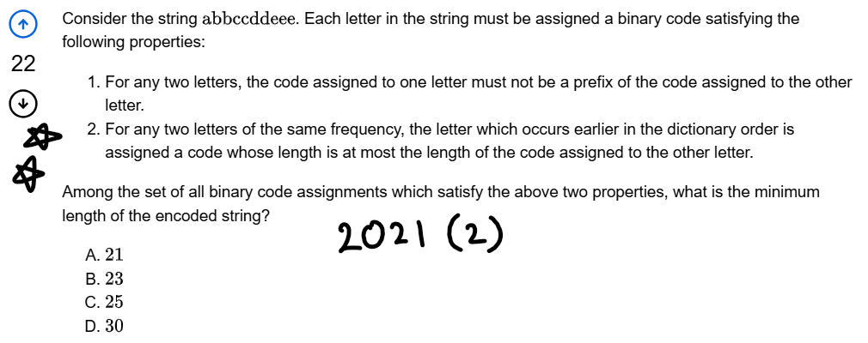

<https://gateoverflow.in/357514/gate-cse-2021-set-2-question-26>

Ink Drawings
Ink Drawings
Ink Drawings
Ink Drawings
Ink Drawings
Ink Drawings
Ink Drawings
Ink Drawings
Ink Drawings
Ink Drawings
Ink Drawings
Ink Drawings
Ink Drawings
Ink Drawings
Ink Drawings
Ink Drawings
Ink Drawings
Ink Drawings
Ink Drawings
Ink Drawings
Ink Drawings
Ink Drawings
Ink Drawings
Ink Drawings
Ink Drawings
Ink Drawings
Ink Drawings
Ink Drawings
Ink Drawings
Ink Drawings
Ink Drawings
Ink Drawings
Ink Drawings
Ink Drawings
Ink Drawings
Ink Drawings
Ink Drawings
Ink Drawings
Ink Drawings
Ink Drawings
Ink Drawings
Ink Drawings
Ink Drawings
Ink Drawings
Ink Drawings
Ink Drawings
Ink Drawings
Ink Drawings
Ink Drawings
Ink Drawings
Ink Drawings
Ink Drawings
Ink Drawings
Ink Drawings
Ink Drawings
Ink Drawings
Ink Drawings
Ink Drawings
Ink Drawings
Ink Drawings
Ink Drawings
Ink Drawings
Ink Drawings
Ink Drawings
Ink Drawings
Ink Drawings
Ink Drawings
Ink Drawings
Ink Drawings
Ink Drawings
Ink Drawings
Ink Drawings
Ink Drawings
Ink Drawings
Ink Drawings
Ink Drawings
Ink Drawings
Ink Drawings
Ink Drawings
Ink Drawings
Ink Drawings
Ink Drawings
Ink Drawings
Ink Drawings
Ink Drawings
Ink Drawings
Ink Drawings
Ink Drawings
Ink Drawings
Ink Drawings
Ink Drawings
Ink Drawings
Ink Drawings
Ink Drawings
Ink Drawings
Ink Drawings
Ink Drawings
Ink Drawings
Ink Drawings
Ink Drawings
Ink Drawings
Ink Drawings
Ink Drawings
Ink Drawings
Ink Drawings
Ink Drawings
Ink Drawings
Ink Drawings
Ink Drawings
Ink Drawings
Ink Drawings
Ink Drawings
Ink Drawings
Ink Drawings
Ink Drawings
Ink Drawings
Ink Drawings
Ink Drawings
Ink Drawings
Ink Drawings
Ink Drawings
Ink Drawings
Ink Drawings
Ink Drawings
Ink Drawings
Ink Drawings


* Some more question to practice
* Take care of the frequencies.

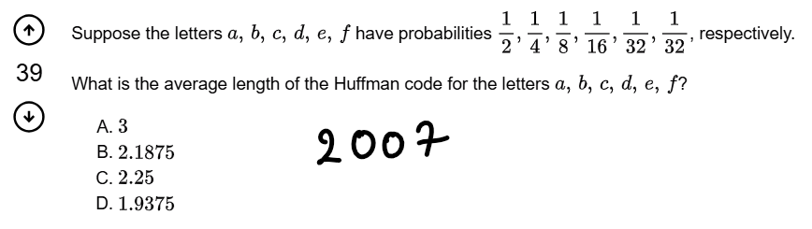

<https://gateoverflow.in/43513/gate-cse-2007-question-77>

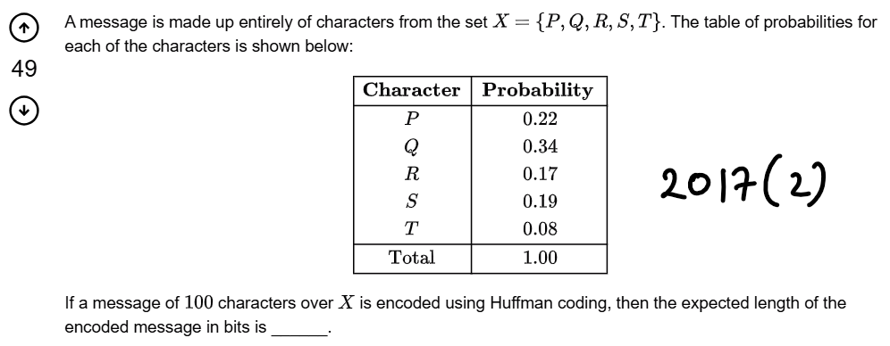

<https://gateoverflow.in/118395/gate-cse-2017-set-2-question-50>

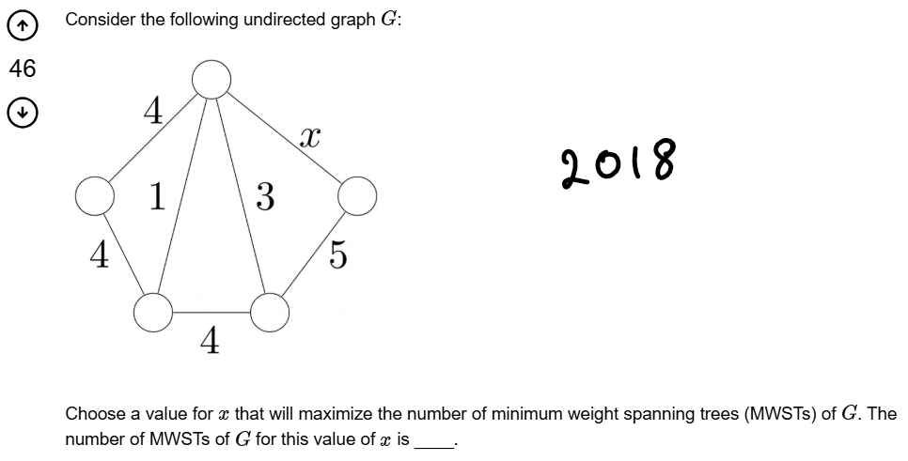

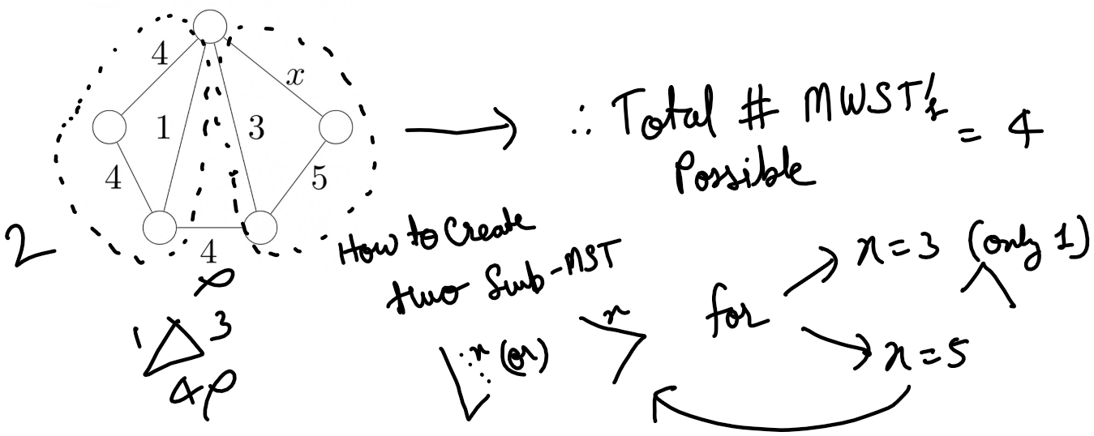

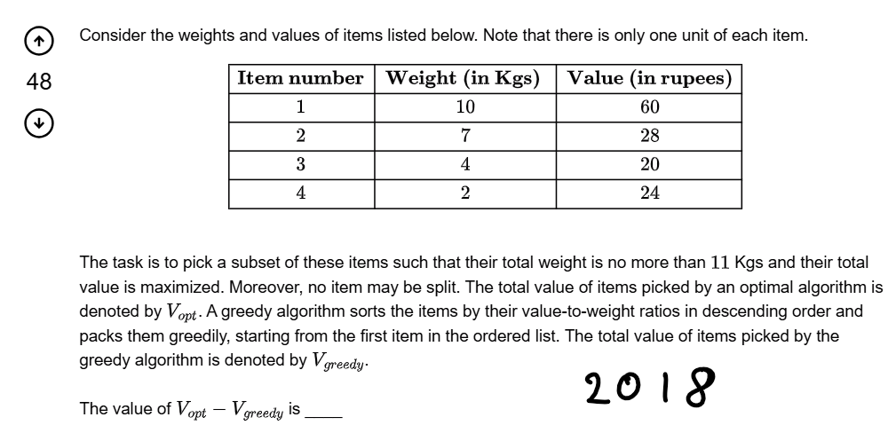

<https://gateoverflow.in/204123/gate-cse-2018-question-48>

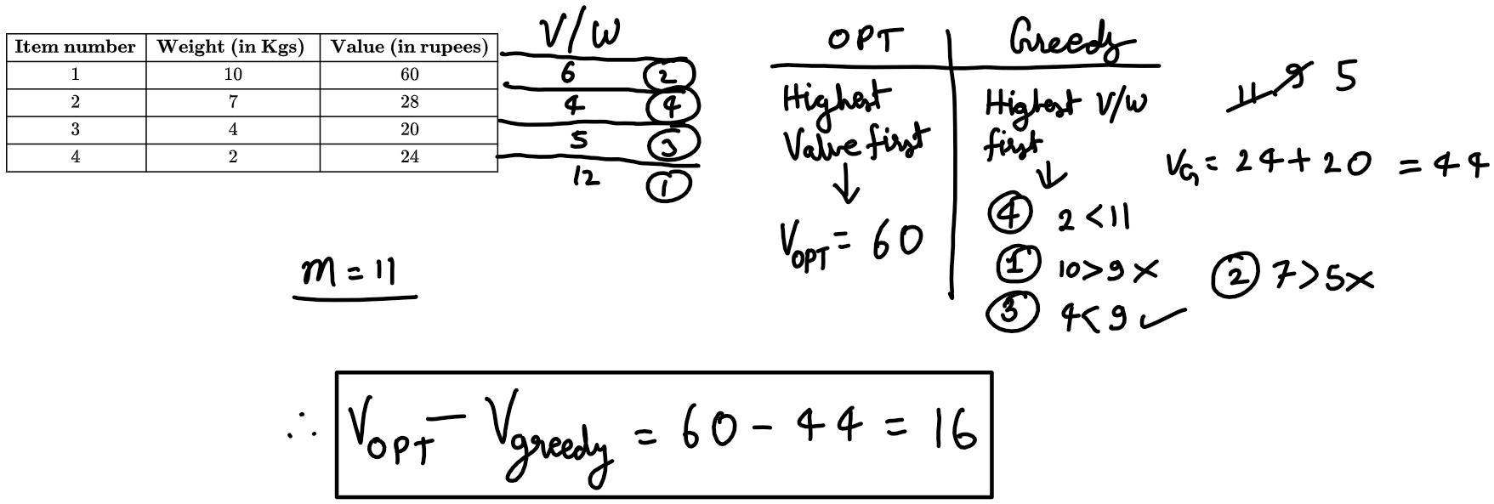

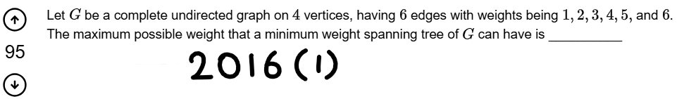

<https://gateoverflow.in/39725/gate-cse-2016-set-1-question-39>

Ink Drawings
Ink Drawings
Ink Drawings
Ink Drawings
Ink Drawings
Ink Drawings
Ink Drawings
Ink Drawings
Ink Drawings
Ink Drawings
Ink Drawings
Ink Drawings
Ink Drawings
Ink Drawings
Ink Drawings
Ink Drawings
Ink Drawings
Ink Drawings
Ink Drawings
Ink Drawings
Ink Drawings
Ink Drawings
Ink Drawings
Ink Drawings
Ink Drawings
Ink Drawings
Ink Drawings
Ink Drawings
Ink Drawings


* Minimum Cost Spanning Tree is always UNIQUE iff all the edge weight are DISTINCE
* While constructing Minimum Cost Spanning Tree if a cycle get’s formed then we remove the heaviest cost edge of that cycle.

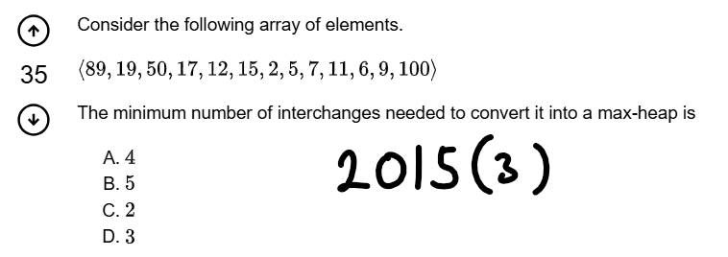

<https://gateoverflow.in/8418/gate-cse-2015-set-3-question-19>

<https://gateoverflow.in/2740/gate-cse-1996-question-2-11>

Ink Drawings
Ink Drawings
Ink Drawings
Ink Drawings
Ink Drawings
Ink Drawings
Ink Drawings
Ink Drawings
Ink Drawings
Ink Drawings
Ink Drawings
Ink Drawings
Ink Drawings
Ink Drawings
Ink Drawings
Ink Drawings
Ink Drawings
Ink Drawings
Ink Drawings
Ink Drawings
Ink Drawings
Ink Drawings
Ink Drawings
Ink Drawings
Ink Drawings
Ink Drawings
Ink Drawings
Ink Drawings
Ink Drawings
Ink Drawings
Ink Drawings
Ink Drawings
Ink Drawings
Ink Drawings
Ink Drawings
Ink Drawings
Ink Drawings
Ink Drawings
Ink Drawings
Ink Drawings
Ink Drawings
Ink Drawings
Ink Drawings
Ink Drawings
Ink Drawings
Ink Drawings
Ink Drawings
Ink Drawings
Ink Drawings
Ink Drawings
Ink Drawings
Ink Drawings
Ink Drawings
Ink Drawings
Ink Drawings
Ink Drawings
Ink Drawings
Ink Drawings
Ink Drawings
Ink Drawings
Ink Drawings
Ink Drawings
Ink Drawings
Ink Drawings
Ink Drawings
Ink Drawings
Ink Drawings
Ink Drawings
Ink Drawings
Ink Drawings
Ink Drawings
Ink Drawings
Ink Drawings
Ink Drawings
Ink Drawings
Ink Drawings
Ink Drawings
Ink Drawings
Ink Drawings
Ink Drawings
Ink Drawings
Ink Drawings
Ink Drawings
Ink Drawings
Ink Drawings
Ink Drawings
Ink Drawings
Ink Drawings
Ink Drawings
Ink Drawings
Ink Drawings
Ink Drawings
Ink Drawings
Ink Drawings
Ink Drawings
Ink Drawings
Ink Drawings
Ink Drawings
Ink Drawings
Ink Drawings
Ink Drawings
Ink Drawings
Ink Drawings
Ink Drawings
Ink Drawings
Ink Drawings
Ink Drawings
Ink Drawings
Ink Drawings


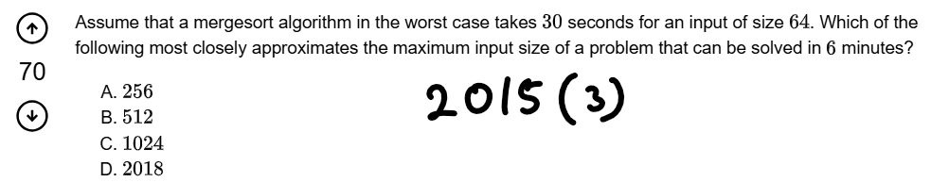

<https://gateoverflow.in/8480/gate-cse-2015-set-3-question-27>

Ink Drawings
Ink Drawings
Ink Drawings
Ink Drawings
Ink Drawings
Ink Drawings
Ink Drawings
Ink Drawings
Ink Drawings
Ink Drawings
Ink Drawings
Ink Drawings
Ink Drawings
Ink Drawings
Ink Drawings
Ink Drawings
Ink Drawings
Ink Drawings
Ink Drawings
Ink Drawings
Ink Drawings
Ink Drawings
Ink Drawings
Ink Drawings
Ink Drawings
Ink Drawings
Ink Drawings
Ink Drawings
Ink Drawings
Ink Drawings
Ink Drawings
Ink Drawings
Ink Drawings
Ink Drawings
Ink Drawings
Ink Drawings
Ink Drawings
Ink Drawings
Ink Drawings
Ink Drawings
Ink Drawings
Ink Drawings
Ink Drawings
Ink Drawings
Ink Drawings
Ink Drawings
Ink Drawings
Ink Drawings
Ink Drawings
Ink Drawings
Ink Drawings
Ink Drawings
Ink Drawings
Ink Drawings
Ink Drawings
Ink Drawings
Ink Drawings
Ink Drawings
Ink Drawings
Ink Drawings
Ink Drawings
Ink Drawings
Ink Drawings
Ink Drawings
Ink Drawings
Ink Drawings
Ink Drawings
Ink Drawings
Ink Drawings
Ink Drawings
Ink Drawings
Ink Drawings
Ink Drawings
Ink Drawings
Ink Drawings
Ink Drawings
Ink Drawings
Ink Drawings
Ink Drawings
Ink Drawings
Ink Drawings
Ink Drawings
Ink Drawings
Ink Drawings
Ink Drawings
Ink Drawings
Ink Drawings
Ink Drawings
Ink Drawings
Ink Drawings
Ink Drawings
Ink Drawings
Ink Drawings
Ink Drawings
Ink Drawings
Ink Drawings
Ink Drawings
Ink Drawings
Ink Drawings
Ink Drawings
Ink Drawings
Ink Drawings
Ink Drawings
Ink Drawings
Ink Drawings
Ink Drawings
Ink Drawings
Ink Drawings
Ink Drawings
Ink Drawings
Ink Drawings
Ink Drawings
Ink Drawings
Ink Drawings
Ink Drawings
Ink Drawings
Ink Drawings
Ink Drawings
Ink Drawings
Ink Drawings
Ink Drawings
Ink Drawings
Ink Drawings
Ink Drawings
Ink Drawings
Ink Drawings
Ink Drawings
Ink Drawings
Ink Drawings
Ink Drawings
Ink Drawings
Ink Drawings
Ink Drawings
Ink Drawings
Ink Drawings
Ink Drawings
Ink Drawings
Ink Drawings
Ink Drawings
Ink Drawings
Ink Drawings
Ink Drawings
Ink Drawings
Ink Drawings
Ink Drawings
Ink Drawings
Ink Drawings
Ink Drawings
Ink Drawings
Ink Drawings
Ink Drawings
Ink Drawings
Ink Drawings
Ink Drawings
Ink Drawings
Ink Drawings
Ink Drawings
Ink Drawings
Ink Drawings
Ink Drawings
Ink Drawings
Ink Drawings
Ink Drawings
Ink Drawings
Ink Drawings
Ink Drawings
Ink Drawings
Ink Drawings
Ink Drawings
Ink Drawings
Ink Drawings


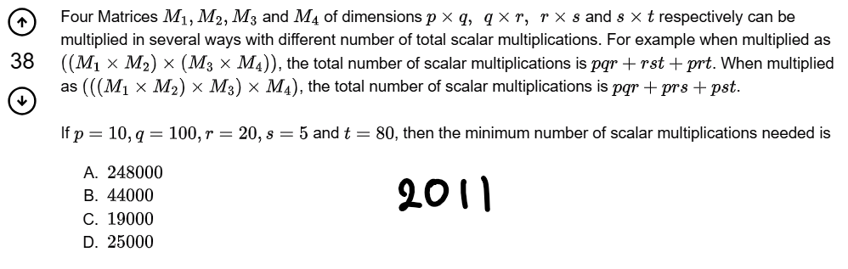

<https://gateoverflow.in/2140/gate-cse-2011-question-38>

Ink Drawings
Ink Drawings
Ink Drawings
Ink Drawings
Ink Drawings
Ink Drawings
Ink Drawings
Ink Drawings
Ink Drawings
Ink Drawings
Ink Drawings
Ink Drawings
Ink Drawings
Ink Drawings
Ink Drawings
Ink Drawings
Ink Drawings
Ink Drawings
Ink Drawings
Ink Drawings
Ink Drawings
Ink Drawings
Ink Drawings
Ink Drawings
Ink Drawings
Ink Drawings
Ink Drawings
Ink Drawings
Ink Drawings
Ink Drawings
Ink Drawings
Ink Drawings
Ink Drawings
Ink Drawings
Ink Drawings
Ink Drawings
Ink Drawings
Ink Drawings
Ink Drawings
Ink Drawings
Ink Drawings
Ink Drawings
Ink Drawings
Ink Drawings
Ink Drawings
Ink Drawings
Ink Drawings
Ink Drawings
Ink Drawings
Ink Drawings
Ink Drawings
Ink Drawings
Ink Drawings
Ink Drawings
Ink Drawings
Ink Drawings
Ink Drawings
Ink Drawings
Ink Drawings
Ink Drawings
Ink Drawings
Ink Drawings
Ink Drawings
Ink Drawings
Ink Drawings
Ink Drawings
Ink Drawings
Ink Drawings
Ink Drawings
Ink Drawings
Ink Drawings
Ink Drawings
Ink Drawings
Ink Drawings
Ink Drawings
Ink Drawings
Ink Drawings
Ink Drawings
Ink Drawings
Ink Drawings
Ink Drawings
Ink Drawings
Ink Drawings
Ink Drawings
Ink Drawings
Ink Drawings
Ink Drawings
Ink Drawings
Ink Drawings
Ink Drawings
Ink Drawings
Ink Drawings
Ink Drawings
Ink Drawings
Ink Drawings
Ink Drawings
Ink Drawings
Ink Drawings
Ink Drawings
Ink Drawings
Ink Drawings
Ink Drawings
Ink Drawings
Ink Drawings
Ink Drawings
Ink Drawings
Ink Drawings
Ink Drawings
Ink Drawings
Ink Drawings
Ink Drawings
Ink Drawings
Ink Drawings
Ink Drawings
Ink Drawings
Ink Drawings
Ink Drawings
Ink Drawings
Ink Drawings
Ink Drawings
Ink Drawings
Ink Drawings
Ink Drawings
Ink Drawings
Ink Drawings
Ink Drawings
Ink Drawings
Ink Drawings
Ink Drawings
Ink Drawings
Ink Drawings
Ink Drawings
Ink Drawings
Ink Drawings
Ink Drawings
Ink Drawings
Ink Drawings
Ink Drawings
Ink Drawings
Ink Drawings
Ink Drawings
Ink Drawings
Ink Drawings
Ink Drawings
Ink Drawings
Ink Drawings
Ink Drawings
Ink Drawings
Ink Drawings
Ink Drawings
Ink Drawings
Ink Drawings
Ink Drawings
Ink Drawings
Ink Drawings
Ink Drawings
Ink Drawings
Ink Drawings
Ink Drawings
Ink Drawings
Ink Drawings
Ink Drawings
Ink Drawings
Ink Drawings
Ink Drawings
Ink Drawings
Ink Drawings
Ink Drawings
Ink Drawings
Ink Drawings
Ink Drawings
Ink Drawings
Ink Drawings
Ink Drawings
Ink Drawings
Ink Drawings
Ink Drawings
Ink Drawings
Ink Drawings
Ink Drawings
Ink Drawings
Ink Drawings
Ink Drawings
Ink Drawings
Ink Drawings
Ink Drawings
Ink Drawings
Ink Drawings
Ink Drawings
Ink Drawings
Ink Drawings
Ink Drawings
Ink Drawings
Ink Drawings
Ink Drawings
Ink Drawings
Ink Drawings
Ink Drawings
Ink Drawings
Ink Drawings
Ink Drawings
Ink Drawings
Ink Drawings
Ink Drawings
Ink Drawings
Ink Drawings
Ink Drawings
Ink Drawings
Ink Drawings
Ink Drawings
Ink Drawings
Ink Drawings
Ink Drawings
Ink Drawings
Ink Drawings
Ink Drawings
Ink Drawings
Ink Drawings
Ink Drawings
Ink Drawings
Ink Drawings
Ink Drawings
Ink Drawings
Ink Drawings
Ink Drawings
Ink Drawings
Ink Drawings
Ink Drawings
Ink Drawings
Ink Drawings
Ink Drawings
Ink Drawings
Ink Drawings
Ink Drawings
Ink Drawings
Ink Drawings
Ink Drawings
Ink Drawings
Ink Drawings
Ink Drawings
Ink Drawings
Ink Drawings
Ink Drawings
Ink Drawings
Ink Drawings
Ink Drawings
Ink Drawings
Ink Drawings
Ink Drawings
Ink Drawings
Ink Drawings
Ink Drawings
Ink Drawings
Ink Drawings
Ink Drawings
Ink Drawings
Ink Drawings
Ink Drawings
Ink Drawings
Ink Drawings
Ink Drawings
Ink Drawings
Ink Drawings
Ink Drawings
Ink Drawings
Ink Drawings
Ink Drawings
Ink Drawings
Ink Drawings
Ink Drawings
Ink Drawings
Ink Drawings
Ink Drawings
Ink Drawings
Ink Drawings
Ink Drawings
Ink Drawings
Ink Drawings
Ink Drawings
Ink Drawings
Ink Drawings
Ink Drawings
Ink Drawings
Ink Drawings
Ink Drawings
Ink Drawings
Ink Drawings
Ink Drawings
Ink Drawings
Ink Drawings
Ink Drawings
Ink Drawings
Ink Drawings
Ink Drawings
Ink Drawings
Ink Drawings
Ink Drawings
Ink Drawings
Ink Drawings


* Some of the best solutions are:-
  + <https://gateoverflow.in/2140/gate-cse-2011-question-38?show=6997#a6997>
  + <https://gateoverflow.in/2140/gate-cse-2011-question-38?show=344541#a344541>

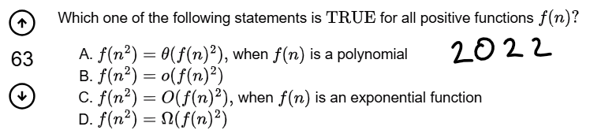

<https://gateoverflow.in/371935/gate-cse-2022-question-1>

Soln:- <https://gateoverflow.in/371935/gate-cse-2022-question-1?show=371951#a371951>

Ink Drawings
Ink Drawings
Ink Drawings
Ink Drawings
Ink Drawings
Ink Drawings
Ink Drawings
Ink Drawings
Ink Drawings
Ink Drawings
Ink Drawings
Ink Drawings
Ink Drawings
Ink Drawings
Ink Drawings
Ink Drawings
Ink Drawings
Ink Drawings
Ink Drawings
Ink Drawings
Ink Drawings
Ink Drawings
Ink Drawings
Ink Drawings
Ink Drawings
Ink Drawings
Ink Drawings
Ink Drawings
Ink Drawings
Ink Drawings
Ink Drawings
Ink Drawings
Ink Drawings
Ink Drawings
Ink Drawings
Ink Drawings
Ink Drawings
Ink Drawings
Ink Drawings
Ink Drawings
Ink Drawings
Ink Drawings
Ink Drawings
Ink Drawings
Ink Drawings
Ink Drawings
Ink Drawings
Ink Drawings
Ink Drawings
Ink Drawings
Ink Drawings
Ink Drawings
Ink Drawings
Ink Drawings
Ink Drawings
Ink Drawings
Ink Drawings
Ink Drawings
Ink Drawings
Ink Drawings
Ink Drawings
Ink Drawings
Ink Drawings
Ink Drawings
Ink Drawings
Ink Drawings
Ink Drawings
Ink Drawings
Ink Drawings
Ink Drawings
Ink Drawings
Ink Drawings
Ink Drawings
Ink Drawings
Ink Drawings
Ink Drawings
Ink Drawings
Ink Drawings
Ink Drawings
Ink Drawings
Ink Drawings
Ink Drawings
Ink Drawings
Ink Drawings
Ink Drawings
Ink Drawings
Ink Drawings
Ink Drawings
Ink Drawings
Ink Drawings
Ink Drawings
Ink Drawings
Ink Drawings
Ink Drawings
Ink Drawings
Ink Drawings
Ink Drawings
Ink Drawings
Ink Drawings
Ink Drawings
Ink Drawings
Ink Drawings
Ink Drawings
Ink Drawings
Ink Drawings
Ink Drawings
Ink Drawings
Ink Drawings
Ink Drawings
Ink Drawings
Ink Drawings
Ink Drawings
Ink Drawings
Ink Drawings
Ink Drawings
Ink Drawings
Ink Drawings
Ink Drawings
Ink Drawings
Ink Drawings
Ink Drawings
Ink Drawings
Ink Drawings
Ink Drawings
Ink Drawings
Ink Drawings
Ink Drawings
Ink Drawings
Ink Drawings
Ink Drawings
Ink Drawings
Ink Drawings
Ink Drawings
Ink Drawings
Ink Drawings
Ink Drawings
Ink Drawings
Ink Drawings
Ink Drawings
Ink Drawings
Ink Drawings
Ink Drawings
Ink Drawings
Ink Drawings
Ink Drawings
Ink Drawings
Ink Drawings
Ink Drawings


Revision Through PYQ Link :- <https://www.youtube.com/live/2kD0FxX_vD8>

1. **Some More PYQ’s**

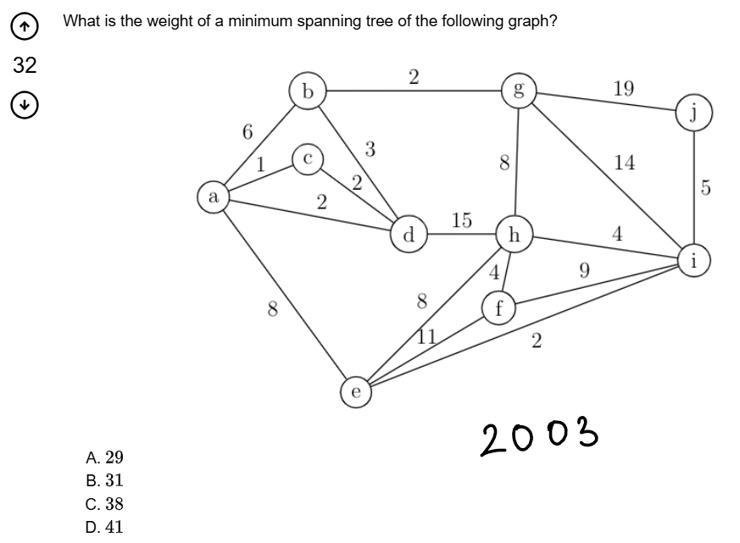

<https://gateoverflow.in/955/gate-cse-2003-question-68>

Ink Drawings
Ink Drawings
Ink Drawings
Ink Drawings
Ink Drawings
Ink Drawings
Ink Drawings
Ink Drawings
Ink Drawings
Ink Drawings
Ink Drawings
Ink Drawings
Ink Drawings
Ink Drawings
Ink Drawings
Ink Drawings
Ink Drawings
Ink Drawings
Ink Drawings
Ink Drawings
Ink Drawings
Ink Drawings
Ink Drawings
Ink Drawings
Ink Drawings
Ink Drawings
Ink Drawings
Ink Drawings
Ink Drawings
Ink Drawings
Ink Drawings
Ink Drawings
Ink Drawings
Ink Drawings
Ink Drawings
Ink Drawings
Ink Drawings
Ink Drawings
Ink Drawings
Ink Drawings
Ink Drawings
Ink Drawings
Ink Drawings
Ink Drawings
Ink Drawings
Ink Drawings
Ink Drawings
Ink Drawings
Ink Drawings
Ink Drawings
Ink Drawings
Ink Drawings
Ink Drawings
Ink Drawings
Ink Drawings
Ink Drawings
Ink Drawings
Ink Drawings
Ink Drawings
Ink Drawings
Ink Drawings
Ink Drawings
Ink Drawings
Ink Drawings
Ink Drawings
Ink Drawings
Ink Drawings
Ink Drawings
Ink Drawings
Ink Drawings
Ink Drawings
Ink Drawings
Ink Drawings
Ink Drawings
Ink Drawings
Ink Drawings
Ink Drawings
Ink Drawings
Ink Drawings
Ink Drawings
Ink Drawings
Ink Drawings
Ink Drawings
Ink Drawings
Ink Drawings
Ink Drawings
Ink Drawings


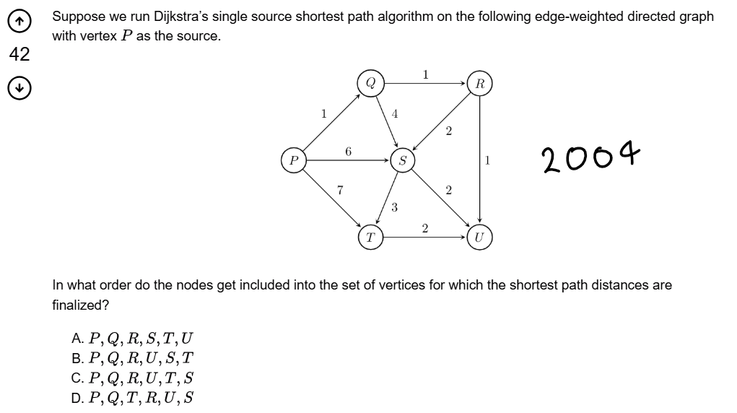

<https://gateoverflow.in/1041/gate-cse-2004-question-44>

Ink Drawings
Ink Drawings
Ink Drawings
Ink Drawings
Ink Drawings
Ink Drawings
Ink Drawings
Ink Drawings
Ink Drawings
Ink Drawings
Ink Drawings
Ink Drawings
Ink Drawings
Ink Drawings
Ink Drawings
Ink Drawings
Ink Drawings
Ink Drawings
Ink Drawings
Ink Drawings
Ink Drawings
Ink Drawings
Ink Drawings
Ink Drawings
Ink Drawings
Ink Drawings
Ink Drawings
Ink Drawings
Ink Drawings
Ink Drawings
Ink Drawings
Ink Drawings
Ink Drawings
Ink Drawings
Ink Drawings
Ink Drawings
Ink Drawings
Ink Drawings
Ink Drawings
Ink Drawings
Ink Drawings
Ink Drawings
Ink Drawings
Ink Drawings
Ink Drawings
Ink Drawings
Ink Drawings
Ink Drawings
Ink Drawings
Ink Drawings
Ink Drawings
Ink Drawings
Ink Drawings
Ink Drawings
Ink Drawings
Ink Drawings
Ink Drawings
Ink Drawings
Ink Drawings
Ink Drawings
Ink Drawings
Ink Drawings
Ink Drawings
Ink Drawings
Ink Drawings
Ink Drawings
Ink Drawings
Ink Drawings
Ink Drawings
Ink Drawings
Ink Drawings
Ink Drawings
Ink Drawings
Ink Drawings
Ink Drawings
Ink Drawings
Ink Drawings
Ink Drawings
Ink Drawings
Ink Drawings
Ink Drawings
Ink Drawings
Ink Drawings
Ink Drawings
Ink Drawings
Ink Drawings
Ink Drawings
Ink Drawings
Ink Drawings
Ink Drawings
Ink Drawings
Ink Drawings
Ink Drawings
Ink Drawings
Ink Drawings
Ink Drawings
Ink Drawings
Ink Drawings
Ink Drawings
Ink Drawings
Ink Drawings
Ink Drawings
Ink Drawings
Ink Drawings
Ink Drawings
Ink Drawings
Ink Drawings
Ink Drawings
Ink Drawings
Ink Drawings
Ink Drawings
Ink Drawings
Ink Drawings
Ink Drawings
Ink Drawings
Ink Drawings
Ink Drawings
Ink Drawings
Ink Drawings
Ink Drawings
Ink Drawings
Ink Drawings
Ink Drawings
Ink Drawings
Ink Drawings
Ink Drawings
Ink Drawings
Ink Drawings
Ink Drawings
Ink Drawings
Ink Drawings
Ink Drawings
Ink Drawings
Ink Drawings
Ink Drawings
Ink Drawings
Ink Drawings
Ink Drawings
Ink Drawings
Ink Drawings
Ink Drawings
Ink Drawings
Ink Drawings
Ink Drawings
Ink Drawings
Ink Drawings
Ink Drawings
Ink Drawings
Ink Drawings
Ink Drawings
Ink Drawings
Ink Drawings
Ink Drawings
Ink Drawings
Ink Drawings
Ink Drawings
Ink Drawings
Ink Drawings
Ink Drawings
Ink Drawings
Ink Drawings
Ink Drawings


